

Requirement & Design Specification
Self-drive Car Rental Platform(SCRP)
Version: 1.0

– Danang, June 2026 –

Record of Changes
Version | Date | A*,M, D | In charge | Change Description
V1.0 | 15/2 | A | KienNTHE11
*A - Added M - Modified D - Deleted

Contents
Record of Changes 2
I. Overview 3
1. User Requirements 4
1.1 Actors 4
1.2 Use Cases 4
2. Overall Functionalities 6
2.1 Screens Flow 6
2.2 Screen Descriptions 6
2.3 Screen Authorization 6
2.4 Non-UI Functions 6
3. System High Level Design 6
3.1 Database Design 6
3.2 Code Packages 6
II. Requirement Specifications 6
1. Authentication & Account Management 6
1.1 UC01- Register Account 6
1.2 UC02- Verify Account 6
1.3 UC03- LogIn 6
1.4 UC04- Login with Google 6
1.5 UC05- Logout 6
1.6 UC06- ForgetPassword 6
1.7 UC07- ResetPassword 6
1.8 UC08 - Change Password 6
1.9 UC09 - Edit Profile 6
1.10 UC10 – KYC - Upload KYC Documents 6
1.11 UC11 - Link Bank Account 6
1.12 UC12- Register as Car Owner 6
2. Vehicle Browsing & Information 6
2.1 UC13- View Vehicle List 6
2.2 UC14 - Search & Filter Vehicles 6
2.3 UC15- View Car Details and Reviews 6
3.1 UC-16_View Policies & FAQ 6
3.2 UC-17_Book Vehicle 6
3.3 UC-18_Payment & Deposit via VietQR 6
3.4 UC19- Track Booking 6
3.5 UC-20_Cancel Booking & Refund Deposit 6
3.6 UC-21_ Vehicle Handover 6
3.7 UC-22_ Rate & Review Service 6
3.8 UC-23_Report Incident 6
3.9 UC24- Submit Complaint 6
3.10 UC25- View Wallet & Transactions 6
3.11 UC-26_ RegisterNewVehicle 6
3.12 UC-27_ ManageVehicleListings 6
3.13 UC-28_ ConfirmRentalRequest 6
4. Vehicle & Revenue Management 6
4.1 UC29- View Revenue Statistics 6
4.2 UC-30_ View & Manage Users 6
4.3 UC-31_ ASSIGN USER ROLES 6
4.4 UC-32_ Approve Vehicles 6
5.1 UC33- Monitor & Resolve Transactions 6
5.2 UC-34_ Manage System Configuration 6
5.3 UC35 - Approve KYC Identity Documents 6
5.4 UC36- Approve New Vehicles (CSKH) 6
5.5 UC37- Handle Support Tickets 6
5.6 UC38 – Handle Complaints 6
5.7 UC39– Handle Incidents 6
5.8 UC40_Manage Reviews 6
5.9 UC41_Statistics & Reports 6
5.10 UC42_AI KYC OCR 6
5.11 UC43 - AI Support Chatbot 6
3. Business Rules 6
III. Design Specifications 6
1. Rental Operations 6
1.1 My Trips 6
1.2 System Access 6
1.3 User profile 6
2. Rental & Trip Operations 6
IV. Appendix 6
1. Assumptions & Dependencies 6
2. Limitations & Exclusions 6
3. Business Rules 6
4. .. 6

I. Overview

1. User Requirements

1.1 Actors
# | Actor | Description
1 | Guest | Unauthenticated user. Authorized only to view listings, perform standard filtering or searching, read reviews, and check global platform regulations.
2 | Renter | Registered users. Allowed to undergo identity validation (KYC), execute rental bookings, process dynamic deposits, confirm handovers, manage digital wallets, file incident metrics, and upload claim evidence.
3 | Car Owner | Registered asset partner. Possesses permissions to perform vehicle onboarding, adjust dynamic pricing configurations, evaluate and process user booking requests, link banking credentials, and read performance statements.
4 | Admin | System manager. Controls security rules, establishes user authorization policies, configures global percentage parameters, executes listing removals, and checks consolidated platform reports.
5 | Customer Service | Operational staff. Evaluates submitted verification records (KYC logs), moderates user review postings, handles support tickets, and facilitates dispute resolutions.

1.2 Use Cases

a. Diagram(s)
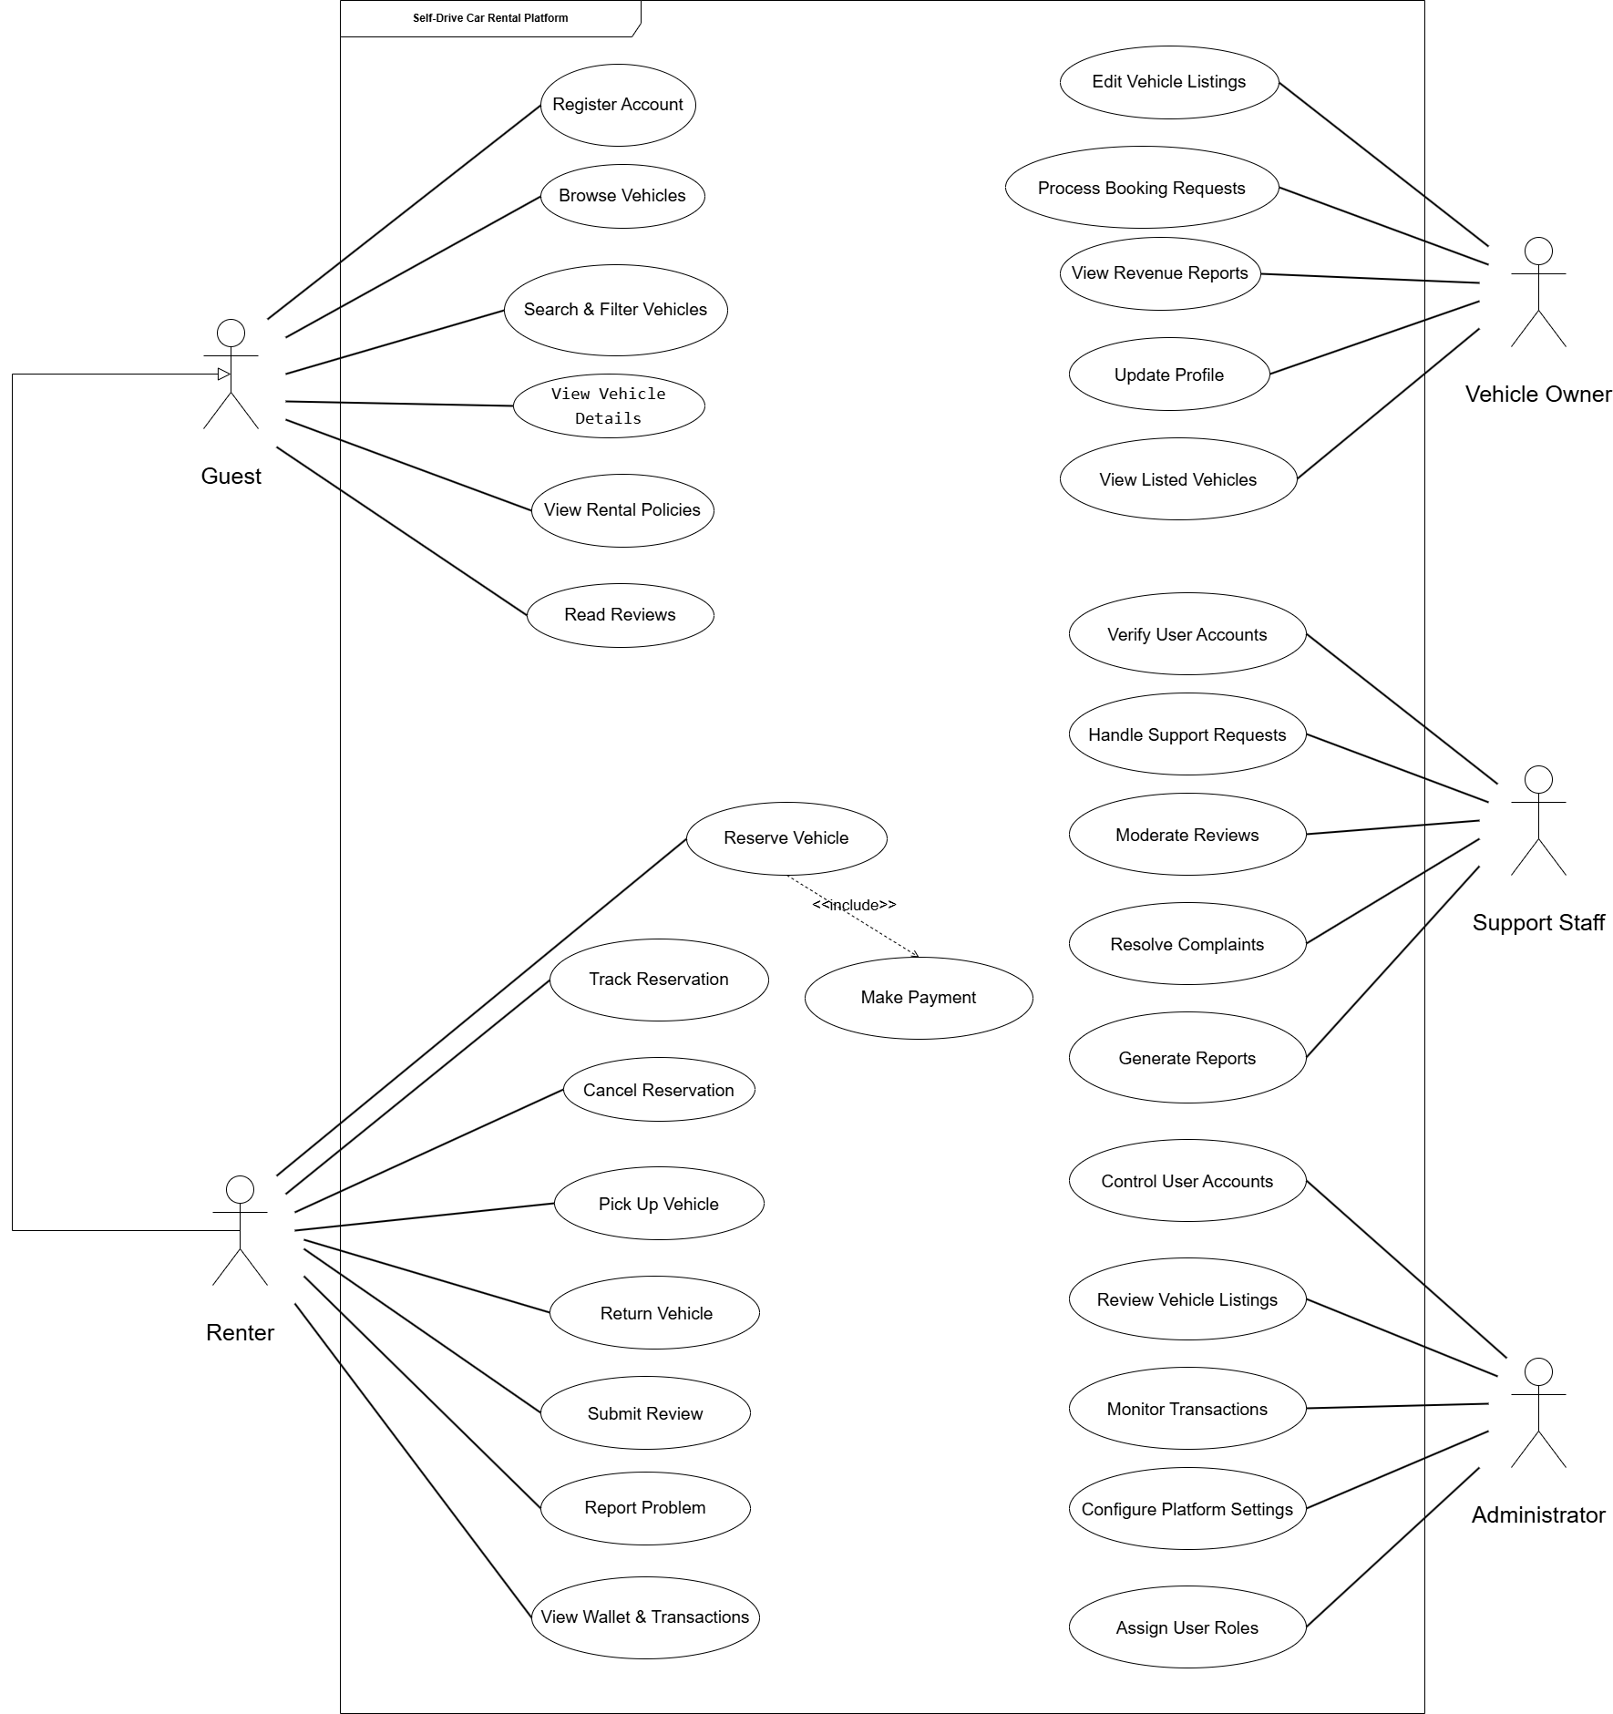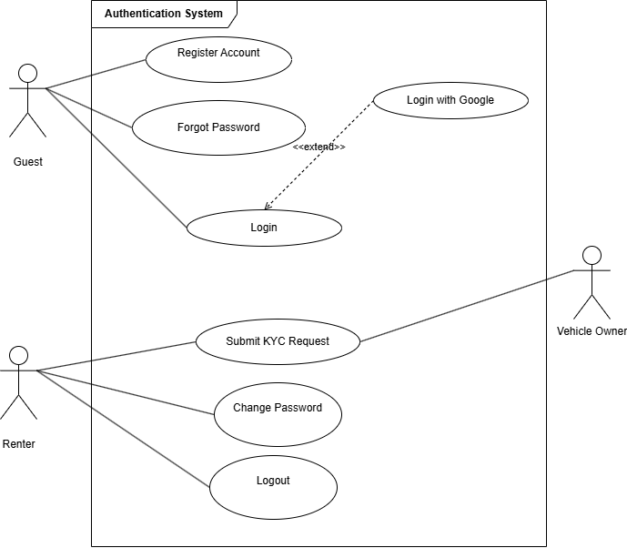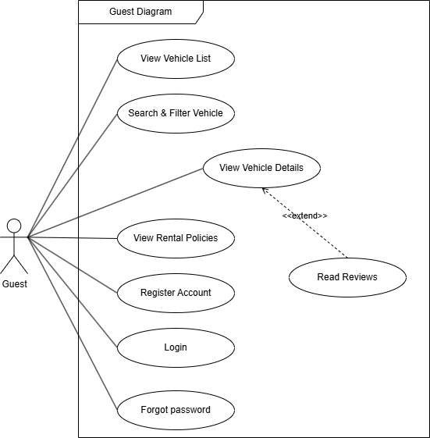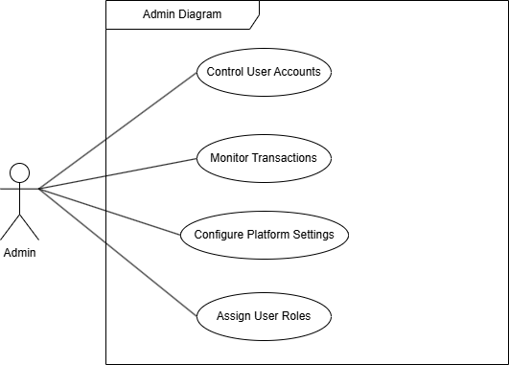

b. Descriptions
ID | Feature | Use Case | Use Case Description
UC01 | Authentication & Account Management | Register Account | Guest registers a new account on the system by providing Email, Full Name, and Password. The system sends a verification token link to the registered email to activate the account.
UC02 | Authentication & Account Management | Verify Email | After registering, the system sends a verification email. The user clicks the token link to activate their account before being allowed to log in.
UC03 | Authentication & Account Management | Login | Registered user logs into the system using Email/Password or via Google OAuth. The system validates credentials and redirects the user to their role-appropriate dashboard.
UC04 | Authentication & Account Management | Login with Google | Guest logs into the platform using their Google account. The system authenticates via Google OAuth and automatically creates or links the user account.
UC05 | Authentication & Account Management | Logout | Authenticated user ends the current session by clicking Logout via the Navbar, clearing the session token to protect account security.
UC06 | Authentication & Account Management | Forgot Password | User requests a password reset by entering their registered email. The system sends a reset link containing a time-limited token to the user's email.
UC07 | Authentication & Account Management | Reset Password | User accesses the password reset link from their email and sets a new password. The system validates the token before allowing the password change.
UC08 | Authentication & Account Management | Change Password | Logged-in user updates their current password by providing the old password and confirming a new one directly from the account settings page.
UC09 | Authentication & Account Management | View & Edit Profile | Authenticated user (Renter, Owner) views and updates personal information including full name, phone number, avatar, and date of birth.
UC10 | Authentication & Account Management | KYC Verification | User (Renter/Car Owner) uploads identity documents (National ID, Driver's License) for verification. The system assists extraction with AI KYC OCR. Documents are reviewed and approved or rejected by Customer Service.
UC11 | Authentication & Account Management | Link Bank Account | Owner or Renter links their bank account to the platform wallet to enable withdrawal of earnings or security deposit refunds.
UC12 | Authentication & Account Management | Register as Car Owner | A Renter upgrades their account role to Car Owner by submitting the required information. Once approved, the user can register and list vehicles on the platform.
UC13 | Vehicle Browsing & Information | View Vehicle List | Guest or Renter views the list of vehicles currently available for rent on the platform, displayed with key info such as name, price per day, location, and thumbnail.
UC14 | Vehicle Browsing & Information | Search & Filter Vehicles | User searches and filters available vehicles by criteria such as price range, brand, category, location, number of seats, and fuel type. Results update in real time based on the current date.
UC15 | Vehicle Browsing & Information | View Vehicle Detail & Reviews | User views the detailed page of a specific vehicle including images, full specifications, features, rental terms, car owner info, and previous customer reviews.
UC16 | Vehicle Browsing & Information | View Policies & FAQ | User reads platform rental regulations, cancellation policies, insurance terms, usage guidelines, and frequently asked questions.
UC17 | Rental & Trip Operations | Book Vehicle | Renter selects a vehicle, sets the rental start and end dates/hours, reviews the total cost, and submits a booking request to the Car Owner.
UC18 | Rental & Trip Operations | Payment & Deposit via VietQR | Renter pays the rental fee and security deposit securely through the VietQR online payment gateway. The system records the transaction and updates the booking status.
UC19 | Rental & Trip Operations | Track Booking | Renter tracks the status of their rental bookings (Pending, Approved, Ongoing, Completed, Cancelled) from the My Trips screen.
UC20 | Rental & Trip Operations | Cancel Booking & Refund | Renter cancels a booking before the rental period begins within the allowed cancellation timeframe. The system processes the applicable refund to the wallet based on the cancellation policy.
UC21 | Rental & Trip Operations | Vehicle Handover | Renter and Car Owner inspect the vehicle condition and confirm the electronic handover form with photos at both vehicle pickup and return.
UC22 | Rental & Trip Operations | Rate & Review Service | After trip completion, Renter gives a star rating and writes a review for both the vehicle and the Car Owner. The review is stored and displayed publicly on the vehicle detail page.
UC23 | Rental & Trip Operations | Report Incident | Renter files an urgent incident report for issues arising during the trip (accident, breakdown, theft) with photo evidence. The report is assigned to Customer Service for resolution.
UC24 | Rental & Trip Operations | Submit Complaint | Renter or Owner submits a formal dispute complaint regarding a trip or transaction. Customer Service receives, reviews evidence, and mediates a resolution between the two parties.
UC25 | Rental & Trip Operations | View Wallet & Transactions | Renter or Owner views their current wallet balance, deposits funds into the wallet, withdraws money to a linked bank account, and views the complete transaction history.
UC26 | Vehicle & Revenue Management | Register New Vehicle | Car Owner registers a new vehicle by entering details including brand, model, plate number, category, pricing, fuel type, features, images, and uploading required legal documents (registration, insurance).
UC27 | Vehicle & Revenue Management | Update Vehicle Listings | Car Owner views, edits, temporarily deactivates, or removes their registered vehicle listings from the platform.
UC28 | Vehicle & Revenue Management | Confirm Rental Request | Car Owner receives incoming booking requests and chooses to approve or reject them within the allowed response timeframe. Approved bookings trigger payment processing.
UC29 | Vehicle & Revenue Management | View Revenue Statistics | Car Owner views revenue reports and earning history, including total earnings per period, per vehicle, and transaction breakdown from completed rentals.
UC30 | Administration & System Control | Monitor User Accounts | Admin views the full list of registered users, searches by name or role, and manages user status including temporarily suspending or permanently deleting accounts that violate platform policies.
UC31 | Administration & System Control | Assign User Roles | Admin assigns or modifies user roles (Renter, Car Owner, Customer Service, Admin) and adjusts permissions within the system.
UC32 | Administration & System Control | Approve Vehicles | Admin reviews new vehicle listing submissions, approves or rejects them based on policy compliance, manages vehicle categories, and removes violating listings from the platform.
UC33 | Administration & System Control | Monitor & Resolve Transactions | Admin monitors all payment flows on the platform, approves or processes deposit refunds, and resolves payment disputes or errors.
UC34 | Administration & System Control | Configure System Settings | Admin manages global platform settings such as platform fee percentage, cancellation timeframes, and notification templates via key-value configuration parameters.
UC35 | Administration & System Control | Verify KYC Documents | Customer Service reviews user-submitted identity documents (National ID, Driver's License) assisted by AI OCR pre-extraction. CSKH approves or rejects the KYC submission with feedback.
UC36 | Vehicle Management | Approve New Vehicles (CSKH) | Customer Service reviews newly registered vehicle listings submitted by Car Owners and approves or rejects them before they go live on the platform.
UC37 | Support | Handle Support Tickets | Customer Service receives, assigns, and responds to support tickets submitted by users regarding issues encountered while using the platform.
UC38 | Support | Handle Complaints | Customer Service receives dispute complaints between Renters and Car Owners, reviews submitted evidence, mediates resolution, and closes the complaint with an outcome.
UC39 | Support | Handle Incidents | Customer Service monitors and manages emergency incident reports submitted by Renters during trips, coordinates resolution, and updates the incident status.
UC40 | Content | Moderate Reviews | Customer Service inspects user-submitted reviews, hides or removes reviews containing inappropriate content, and reports violations to Admin.
UC41 | Reporting | Statistics & Reports | Customer Service compiles and submits weekly/monthly reports to Admin covering incident counts, complaint resolutions, KYC processing stats, and user violation summaries.
UC42 | AI Integration | AI KYC OCR | The system automatically extracts identity information (full name, ID number, date of birth, address) from uploaded KYC documents using AI OCR, pre-filling fields for Customer Service review.
UC43 | AI Integration | AI Support Chatbot | The system provides an AI-powered chatbot on the Contact/Support page that answers common user questions automatically, reducing load on Customer Service agents.
UC44 | Manage Vouchers
UC45 | AI Face Biometric Verification
UC46 | AI Admin Assistant

2. Overall Functionalities

2.1 Screens Flow
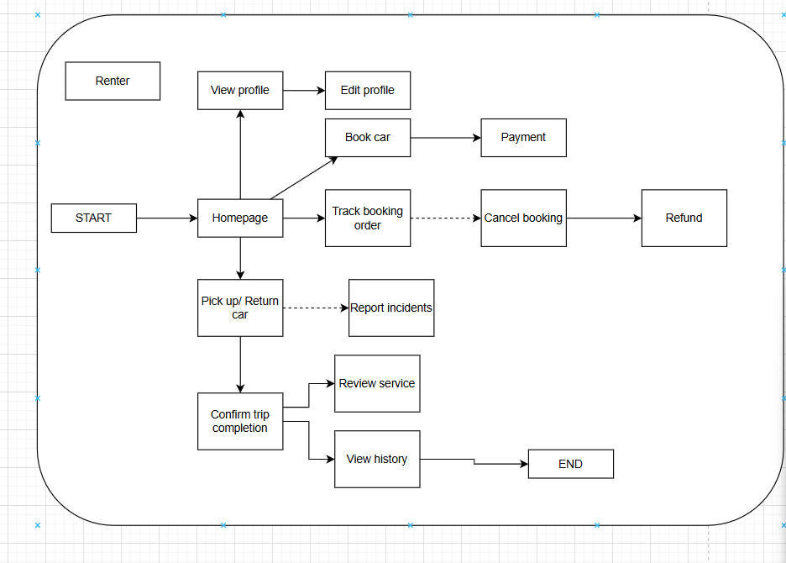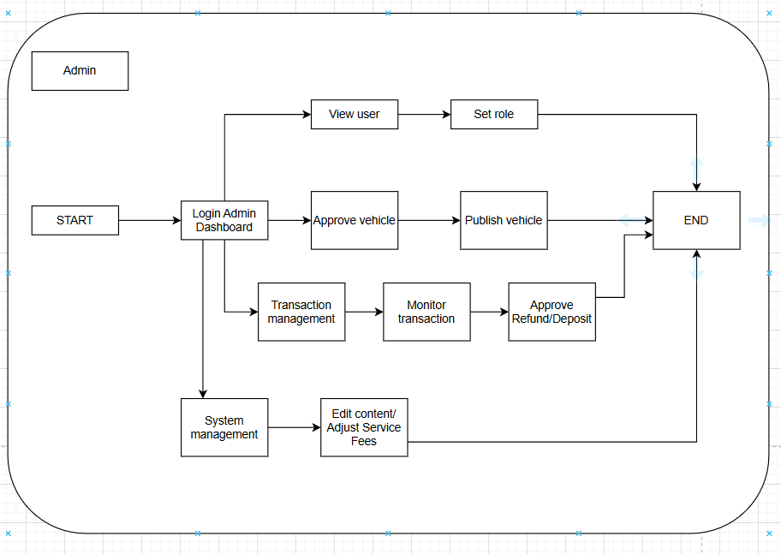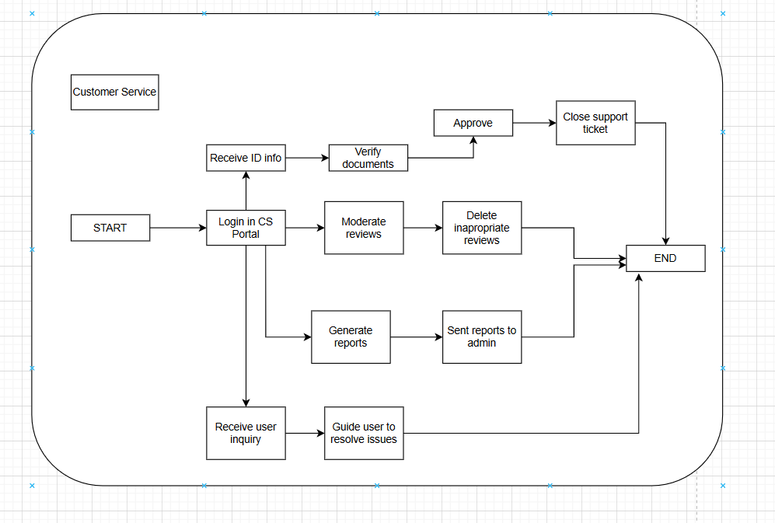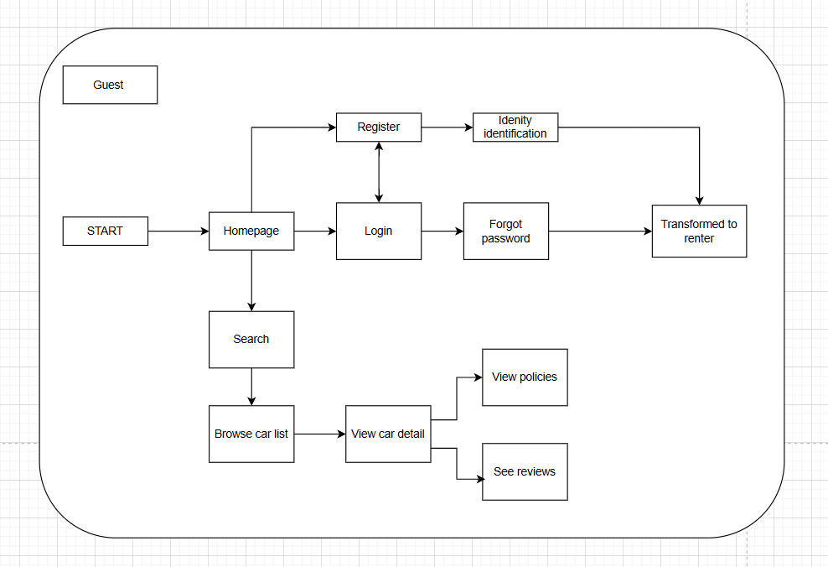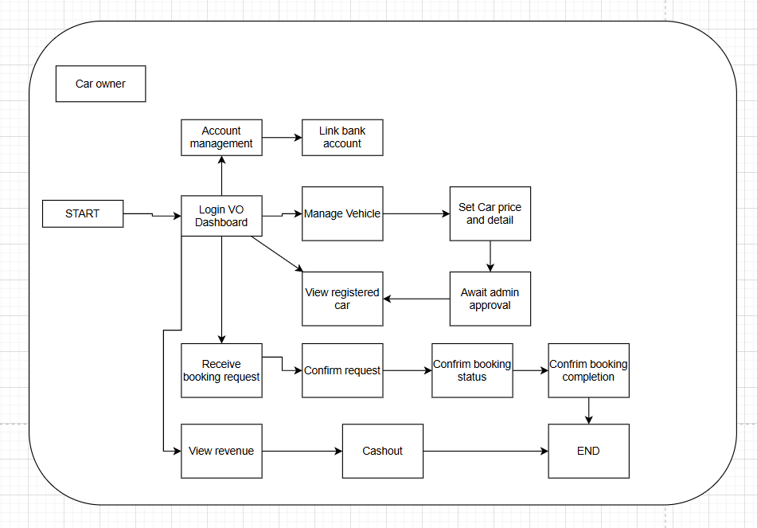

2.2 Screen Descriptions
# | Screen | Feature | Description
1 | Home / Landing Page | Home / Landing Page Overview | Acts as the primary entry marketplace for all actors to discover available vehicles, featuring quick routing navigation tools, recommended car clusters, and active promotional campaigns.
2 | Home / Landing Page | Location Input Filter | A text field and dynamic dropdown synchronized with the system location database, allowing users to select the target city/district for car pickup.
3 | Home / Landing Page | Pick-up Date & Time Picker | A calendar and time selection widget. Constraint: Must be greater than or equal to the current system date and time. It sets the starting timeline for the hire.
4 | Home / Landing Page | Return Date & Time Picker | A calendar and time selection widget. Constraint: Must be strictly greater than the selected Pick-up Date & Time. It establishes the vehicle return deadline.
5 | Home / Landing Page | "Tìm xe ngay" Action Button | A primary interactive button that validates the input parameters and routes the user's query payloads directly to the Search Dashboard.
6 | Home / Landing Page | Vehicle Grid Display | A composite catalog layout showing car cards (images, model names, daily rental prices, and location strings) matching specific dynamic system asset IDs.
7 | Search & Filter Dashboard | Search & Filter Dashboard Overview | Displays real-time dynamic search results and catalog items based on user criteria, featuring a left-aligned multi-criteria filter panel.
8 | Search & Filter Dashboard | Transmission Type Filter | A checkbox group with options [Số sàn, Số tự động], triggering a real-time reactive UI filter to sort vehicles based on transmission mechanics.
9 | Search & Filter Dashboard | Fuel Type Filter | A checkbox group with options [Xăng, Dầu, Điện], narrowing down the displayed vehicle grid records based on engine power sources.
10 | Search & Filter Dashboard | Seat Capacity Filter | A checkbox group with options [4 chỗ, 5 chỗ, 7 chỗ] used to refine marketplace search boundaries according to the vehicle cabin size.
11 | Search & Filter Dashboard | Sort Selection Menu | A dropdown list with options [Giá thấp đến cao, Giá cao đến thấp, Đánh giá tốt] to instantly re-order the active UI grid array client-side without page reloads.
12 | Search & Filter Dashboard | Car Card Redirection Link | An interactive hyperlink overlay on each product card mapped to a unique Car ID. Clicking redirects the user to the Vehicle Details Profile screen.
13 | Vehicle Details Profile | Vehicle Details Profile Overview | Shows a comprehensive profile for an individual vehicle, presenting verified technical specifications, past ratings, owner credentials, and booking configurations.
14 | Vehicle Details Profile | High-Res Image Gallery | A media carousel layout showcasing internal, external, and registration state photos uploaded and verified directly by the Car Owner.
15 | Vehicle Details Profile | Technical Specification Matrix | An icon-driven status display showing boolean presence badges for hardware features like GPS/Maps, Bluetooth, Backup Camera, and Dashcam.
16 | Vehicle Details Profile | Timeline Duration Adjuster | An inline calendar picker synchronized with the owner's availability schedule, letting renters recalculate rental days directly on the details view.
17 | Vehicle Details Profile | Itemized Price Output | A dynamic numeric text label formatting currency strings ($VND$), displaying the calculated total rental cost based on day spans and active surcharges.
18 | Vehicle Details Profile | "ĐẶT XE" Booking Trigger | A primary action button. Constraint: Active only when the User Session is alive and KYC Status = Verified. Redirects the renter payload to the Checkout screen.
19 | Booking Summary & Checkout | Booking Summary & Checkout Overview | Provides the secure transactional checkout interface where renters review legal contract data, verify documentation, and process escrow payments.
20 | Booking Summary & Checkout | Verified Renter Metadata Card | A read-only summary container extracting user parameters (Full Name, Phone Number, and Driver's License verification status) from the database.
21 | Booking Summary & Checkout | Financial Pricing Ledger | An itemized financial statement data grid that breaks down base rental fees, required platform escrow security deposit amounts (Tiền cọc), and service fees.
22 | Booking Summary & Checkout | Payment Gateway Radio Selector | A radio button group with options [VNPAY Sandbox Gateway, Internal Digital Wallet Balance] to route and validate payment transaction sequences.
23 | Booking Summary & Checkout | Promo Code Coupon Input | A text input field checked against active promotional database entities to calculate dynamic discount deductions from the total base rental cost.
24 | Booking Summary & Checkout | "Thanh toán cọc" Action Button | A primary transactional button. Constraint: Executable only upon checking the "Terms & Conditions" box. Fires secure APIs to lock escrow funds.
25 | User Booking History Dashboard | User Booking History Dashboard Overview | A unified tracking panel mapping operational lifecycle milestones for Renters and Car Owners to manage active and historical rental trips.
26 | User Booking History Dashboard | Status Tab Navigation Bar | A navigation tab control containing options [Tất cả, Chờ duyệt, Đã duyệt, Đang thuê, Hoàn thành, Đã hủy] to sort historical log data views.
27 | User Booking History Dashboard | Dynamic Status Color Badge | A color-coded structural label mapping core status model states (Yellow: Pending Approval, Green: Active Rental, Gray: Completed) for immediate visual feedback.
28 | User Booking History Dashboard | "Hủy chuyến" Control Button | An action trigger. Constraint: Visible only when current state = Chờ duyệt or time is $\ge 24h$ before pickup. Cancels the booking and triggers deposit returns.
29 | User Booking History Dashboard | "Nhận xe / Trả xe" Form Trigger | An action trigger. Constraint: Visible during the official scheduled pickup or return timeline windows. Launches the digital electronic handover checklist interface.
30 | User Booking History Dashboard | "Đánh giá" Modal Button | An action button. Constraint: Visible only when booking status = Hoàn thành and review is unsubmitted. Opens a modal box for star ratings and feedback.

2.3 Screen Authorization
# | Screen | Guest | Renter | Vehicle  Owner | Admin | Customer Service
1 | Home / Landing Page | X | X | X | X | X
2 | Vehicle Search & Filter Dashboard | X | X | X | X | X
3 | Vehicle Details Profile | X | X | X | X | X
4 | Sign In / Sign Up Portal | X | X | X | X | X
5 | Forgot Password & Recovery Screen | X | X | X | X | X
6 | User Profile Management Dashboard |  | X | X | X | X
7 | Identity Verification Upload Portal (KYC) |  | X | X
8 | Booking Summary & Checkout (Deposit) |  | X
9 | User Booking History Dashboard (Tracking) |  | X | X
10 | Internal Chat & Communication Interface |  | X | X
11 | Vehicle Onboarding & Registration Wizard |  |  | X
12 | Vehicle Asset Management Dashboard |  |  | X
13 | Car Owner Financial & Revenue Dashboard |  |  | X
14 | System Digital Wallet Dashboard |  | X | X
15 | Digital Handover Checklist Form (Pick-up/Return) |  | X | X
16 | Admin User Directory & Account Control Portal |  |  |  | X
17 | Admin Vehicle Listing Moderation Dashboard |  |  |  | X
18 | Admin Escrow & Transaction Logs Management |  |  |  | X
19 | Admin System Settings & Pricing Configurations |  |  |  | X
20 | CS Staff KYC Document Approval Dashboard |  |  |  |  | X
21 | CS Staff Helpdesk & Support Ticket Center |  |  |  |  | X
22 | CS Staff Content & Review Moderation Panel |  |  |  |  | X
23 | CS Staff Incident & Dispute Claims Resolver |  |  |  |  | X

2.4 Non-UI Functions
# | Feature | System Function | Description
1 | User Authentication | Sign in with Google OAuth2 | Allows users to authenticate and log into the system instantly using their registered Google account credentials via a secure background handshake.
2 | Email Token & Alert Service | Forgot Password Recovery | When a user requests a password recovery, the background token subsystem generates a secure OTP/reset link and dispatches an automated notification email within a strict 20-minute validity boundary.
3 | Email Token & Alert Service | Automated Booking Status Alerts | Runs in the background to instantly deliver confirmation or rejection emails to Renters as soon as a Car Owner approves or rejects a dynamic booking contract state.
4 | Image Processing Service | Cloud Asset & KYC Data Upload | Automatically triggered whenever a Renter uploads identity records (CCCD, driving permit) or a Car Owner registers vehicle asset photos. It runs in the background to compress, sanitize, and store files safely (supporting .png, .jpg, .jpeg, .svg formats).
5 | Payment Gateway System | Real-time Payment & Escrow Initialization | When a renter clicks the checkout button, a background API worker handles secure handshake signatures with external services (like the VNPAY Sandbox), calculates the platform service cut, and places the dynamic security deposit (Tiền cọc) into secure escrow hold states.
6 | Payment Gateway System | Automated Escrow Refund System | Upon successful, conflict-free trip termination or early qualified cancellation requests, an background routing process evaluates data rules and prompts automatic refund pipelines for the renter's deposit asset.
7 | Ledger Tracking System | Live Financial Surcharge & Fee Calculation | Executes underlying mathematical balance algorithms to dynamically audit overall car usage counts, calculate total trip overhead margins based on exact days, and accurately log final revenue splits onto the Car Owner's balance history table.
8 | Database Scheduler System | Vehicle Availability State Automation | A background cron-job routinely loops through reservation date parameters to flip vehicle calendar availability state markers from active marketplace displays to hidden indicators while a trip is underway.

3. System High Level Design

3.1 Database Design

a. Database Schema

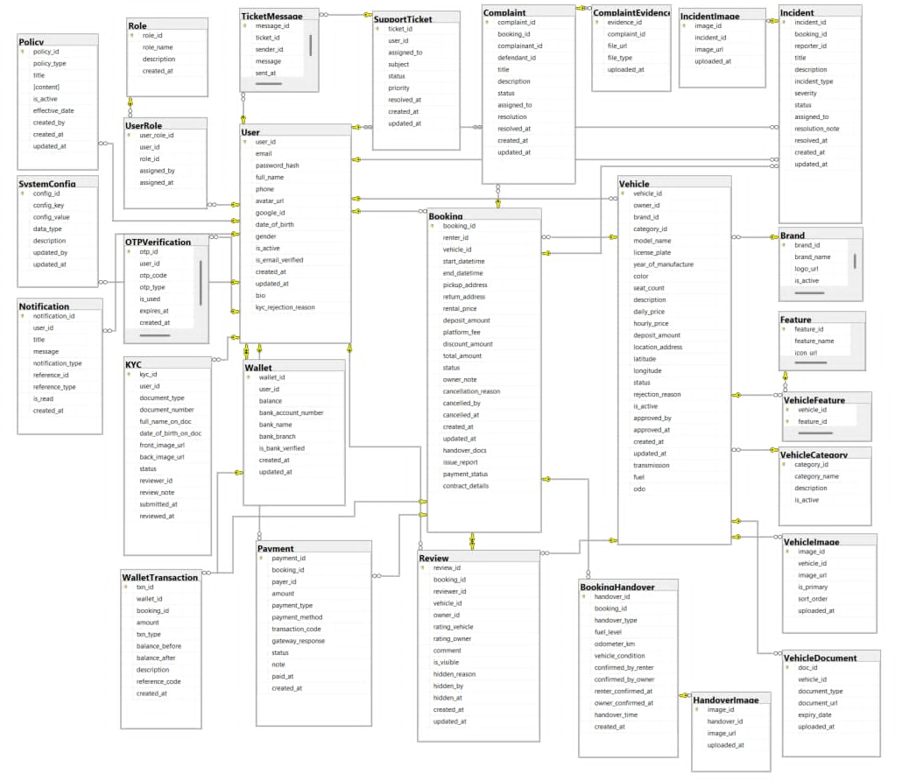

b. Table Descriptions
# | Table | Description
01 | Role | Stores role definitions within the system (Guest, Renter, CarOwner, Admin, CustomerService).  - Primary keys: role_id  - Foreign keys: None
02 | User | Store account information, personal profiles, and user login credentials  - Primarykeys: user_id  -Foreign keys: None
03 | UserRole | A junction table for role-based access control, linking users to their assigned roles.  - Primary keys: user_role_id  - Foreign keys: user_id, role_id, assigned_by
04 | OTPVerification | Stores OTP codes used for email verification or password recovery.  - Primary keys: otp_id  - Foreign keys: user_id
05 | KYC | Stores identity verification information and documents (National ID, Driver's License, etc.).  - Primary keys: kyc_id  - Foreign keys: user_id, reviewer_id
06 | Brand | Stores information about vehicle brands (Toyota, Honda, VinFast, etc.).  - Primary keys: brand_id  - Foreign keys: None
07 | VehicleCategory | Stores vehicle classification data (Sedan, SUV, Hatchback, MPV, etc.).  - Primary keys: category_id  - Foreign keys: None
08 | Vehicle | Stores detailed information about vehicles registered on the platform, including pricing, specifications, and status.  - Primary keys: vehicle_id  - Foreign keys: owner_id, brand_id, category_id, approved_by
09 | VehicleImage | Stores detailed images of the vehicles.  - Primary keys: image_id  - Foreign keys: vehicle_id
10 | VehicleDocument | Stores legal documents associated with vehicles (Registration, Insurance, Technical Inspection).  - Primary keys: doc_id  - Foreign keys: vehicle_id
11 | Feature | A catalog of vehicle amenities and support features (GPS, Dash cam, Bluetooth, etc.).  - Primary keys: feature_id  - Foreign keys: None
12 | VehicleFeature | A junction table linking vehicles to their equipped features.  - Primary keys: vehicle_id, feature_id  - Foreign keys: vehicle_id, feature_id
13 | Booking | Stores vehicle rental transaction details between renters and car owners, including costs and trip status.  - Primary keys: booking_id  - Foreign keys: renter_id, vehicle_id, cancelled_by
14 | BookingHandover | Electronic handover record, documenting the vehicle's condition, odometer, and fuel level during pickup and return.  - Primary keys: handover_id  - Foreign keys: booking_id
15 | HandoverImage | Stores photographic evidence taken during the vehicle handover process.  - Primary keys: image_id  - Foreign keys: handover_id
16 | Payment | Records detailed payment transactions (rental fees, deposits, refunds) processed via payment gateways or wallets.  - Primary keys: payment_id  - Foreign keys: booking_id, payer_id
17 | Wallet | Stores the user's electronic wallet information and current balance on the platform.  - Primary keys: wallet_id  - Foreign keys: user_id
18 | WalletTransaction | A ledger storing the complete history of wallet balance fluctuations (top-ups, withdrawals, payments) over time.  - Primary keys: txn_id  - Foreign keys: wallet_id, booking_id
19 | Review | Stores ratings and reviews submitted by renters for vehicles and car owners after a trip.  - Primary keys: review_id  - Foreign keys: booking_id, reviewer_id, vehicle_id, owner_id, hidden_by
20 | Incident | Records issues that occur during a trip (accidents, breakdowns, traffic violations) for resolution.  - Primary keys: incident_id  - Foreign keys: booking_id, reporter_id, assigned_to
21 | IncidentImage | Stores photographic evidence for reported incidents.  - Primary keys: image_id  - Foreign keys: incident_id
22 | Complaint | Records disputes and complaints between renters and car owners for Customer Service to resolve.  - Primary keys: complaint_id  - Foreign keys: booking_id, complainant_id, defendant_id, assigned_to
23 | ComplaintEvidence | Stores evidence files (images, videos, documents) related to a specific complaint.  - Primary keys: evidence_id  - Foreign keys: complaint_id
24 | SupportTicket | Manages support requests (tickets) submitted by users to the Customer Service department.  - Primary keys: ticket_id  - Foreign keys: user_id, assigned_to
25 | TicketMessage | Stores the conversation history and messages within a support ticket.  - Primary keys: message_id  - Foreign keys: ticket_id, sender_id
26 | Notification | Stores system notifications sent to users (trip reminders, payment alerts, etc.).  - Primary keys: notification_id  - Foreign keys: user_id
27 | Policy | Stores platform policies (rental terms, insurance, cancellation rules).  - Primary keys: policy_id  - Foreign keys: created_by
28 | SystemConfig | Manages system configuration parameters as Key-Value pairs (platform fee percentage, cancellation timeframes, etc.).  - Primary keys: config_id  - Foreign keys: updated_by

3.2 Code Packages

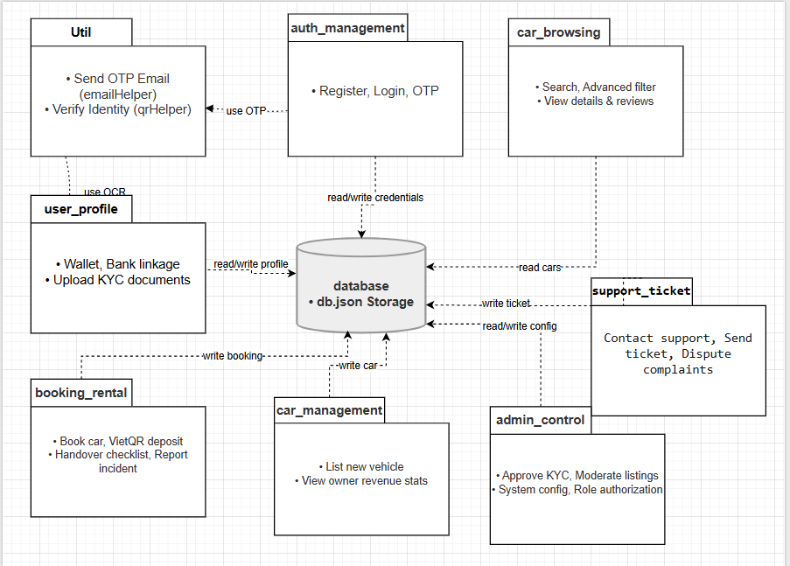
Package descriptions
No | Package | Description
01 | Auth management | Handles user authentication processes, including account registration, password login, Google OAuth integration, and OTP-based email verification.
02 | user_profile | Manages renter and owner profile details, bank account linkage, and wallet balances (depositing and withdrawing funds).
03 | car_browsing | Allows users to search, filter, view details, rental policies, and read reviews of vehicles available for rent.
04 | booking_rental | Manages the complete car rental process, including booking creation, deposit payment via VietQR, electronic handover checklist, and accident reporting.
05 | car_management | Handles car owners' actions, including listing new vehicles, viewing owned cars, and monitoring revenue statistics.
06 | support_ticket | Manages customer support operations, allowing users to submit support tickets and initiate transaction disputes.
07 | admin_control | Governs administrative operations, such as KYC document approval, vehicle listing moderation, support ticket replies, and role configuration.
08 | Util | Contains common utility helper modules, such as the SMTP mail sender (emailHelper.js) and the CCCD QR scanner (qrHelper.js).
09 | database | Manages data persistence operations, encapsulating the reading and writing of records inside the database file (db.json).

II. Requirement Specifications

1. Authentication & Account Management

1.1 UC01- Register Account

a. Functionalities
FUNCTIONAL DESCRIPTION
UC ID and Name: | UC01 – Register Account
Created By: | Minh Đức | Date Created: | June 2026
Primary Actor: | Guest | Secondary Actors: | Email System
Trigger: | Guest clicks the "Register" button on the Home or Login page.
Description: | A Guest fills in their personal information (Email, Full Name, Password) to create a new account. The system saves the account with status "Pending Verification" and sends a verification email.
Preconditions: | PRE-1: User has not logged in (Guest).  PRE-2: The email address has not been registered before.
Postconditions: | POST-1: A new account is created with status "Pending Verification".  POST-2: A verification email containing a token link is sent to the registered email.  POST-3: The registration event is logged.
Normal Flow: | 1.0 Register Account  1. Guest navigates to the Register page.  2. Guest enters: Email, Full Name, Password, Confirm Password.  3. Guest clicks "Register".  4. System validates the input (see 1.0.E1, 1.0.E2, 1.0.E3).  5. System creates the account with status "Pending Verification".  6. System sends a verification email with a token link (valid 24 h).  7. System displays: "Registration successful. Please check your email to verify your account."
Alternative Flows: | None
Exceptions: | 1.0.E1 – Email already registered  1. System shows: "This email is already registered. Please use a different email or log in."  2. Guest may correct the email and retry.  1.0.E2 – Password does not meet requirements  1. System shows: "Password must be at least 8 characters and include letters and numbers."  2. Guest updates the password and retries.  1.0.E3 – Confirm Password does not match  1. System shows: "Confirm Password does not match."  2. Guest corrects the field and retries.
Priority: | Must Have – High | Frequency of Use: | Moderate; peaks at platform launch.
Business Rules: | BR01, BR02, BR03
Other Information: | Unverified accounts cannot log in. Token expires after 24 h.
Assumptions: | Email service is available and functioning normally.

b. Business Rules

ID | Business Rule | Description
BR01 | Unique Email | Each email address can only be used to register one account.
BR02 | Password Policy | Password ≥ 8 characters, containing at least one letter and one number. Stored using bcrypt.
BR03 | Email Verification | Account must be verified via email link before login. Token expires after 24 hours.

1.2 UC02- Verify Account

a. Functionalities

FUNCTIONAL DESCRIPTION
UC ID and  Name: | UC02 - Verify Account
Created By: | Văn Dương | Date Created: | June 2026
Primary Actor: | Guest / Unverified User | Secondary  Actors: | Email System
Trigger: | User clicks the verification link in their email or enters the 6-digit OTP code on the verification page.
Description: | Verifies the user’s email address using a token link or OTP code. After successful verification, the account status changes from Pending Verification to Active, allowing the user to log in.
Preconditions: | PRE-1: User has registered an account with status Pending Verification.  PRE-2: isEmailVerified = 0.  PRE-3: A verification token or OTP has been generated and sent to the user’s email.
Postconditions: | POST-1: Account status is updated to Active.  POST-2: isEmailVerified = 1.  POST-3: Verification token or OTP is cleared, marked as used, or invalidated.  POST-4: Verification event is logged.
Normal Flow: | 3.0 Verify Account via Email Link  1. User opens the verification email sent by the system.  2. User clicks the verification link containing the token.  3. System receives the token from the URL parameters.  4. System validates the token against the database.  5. System checks whether the token is valid and has not expired.  6. System updates isEmailVerified = 1.  7. System changes account status to Active.  8. System invalidates or marks the token as used.  9. System displays: "Xác thực tài khoản thành công! Bây giờ bạn đã có thể đăng nhập."
Alternative  Flows: | 3.0.A1 - Verify via 6-digit OTP Code  1. User navigates to the verification screen.  2. User enters the 6-digit OTP code.  3. User clicks the "Verify" button.  4. System validates the OTP code.  5. System updates isEmailVerified = 1.  6. System changes account status to Active.  7. System clears or marks the OTP as used.  8. System redirects user to Login page.
Exceptions: | 3.0.E1 - Invalid Token/OTP  1. Token/OTP does not match database records.  2. System shows: "Mã xác thực không hợp lệ hoặc không tồn tại."  3.0.E2 - Expired Token/OTP  1. Token/OTP has exceeded its expiration time.  2. System shows: "Mã xác thực đã hết hạn."  3. System provides an option to request a new code.  3.0.E3 - Account Already Verified  1. System detects that the account has already been verified.  2. System shows: "Tài khoản này đã được xác thực trước đó."
Priority: | Must Have - High | Frequency of  Use: | High; used by every email/password account during registration.
Business  Rules: | BR04 ,BR05,BR06,BR07,BR08
Other  Information: | OTP code consists of 6 random digits. Verification link contains a secure token.
Assumptions: | User can access their email inbox to retrieve the verification link or OTP.

b. Business Rules
ID | Business Rule | Business Rule Description
BR04 | Login Restriction | Unverified accounts are not allowed to log in.
BR05 | OTP Format | OTP code must consist of 6 random digits.
BR06 | OTP Expiration | OTP code expires after 10 minutes.
BR07 | Link Expiration | Email verification link expires after 24 hours.
BR08 | One-time Use | A verification token or OTP can only be used once.

1.3 UC03- LogIn

a. Functionalities
UC ID and Name: | UC 3 - LogIn
Created By: | KhanhBN | Date Created: | 16/June/2026
Primary Actor: | Guest | Secondary Actors: | None
Trigger: | User clicks the "Login" button on the Home page or any page requiring authentication.
Description: | A registered user provides their credentials (Email and Password) to authenticate and access the system's restricted functionalities based on their role.
Preconditions: | That user has an active, verified account in the system, and that user is not currently logged in.
Postconditions: | The user is successfully authenticated and redirected to the Dashboard/previous page. A secure session is created for the user. The login event is logged.
Normal Flow: | 3.0. Log In  1. User navigates to the Login page.  2. User enters: Email and Password.  3. User clicks "Login".  4. System validates the input format and credentials (see 1.0.E1, 1.0.E2, 1.0.E3).  5. System creates a user session/token.  6. System redirects user to the Dashboard/Home page with logged-in status.
Alternative Flows: | None
Exceptions: | 1.0.E1 – Email not found  1. System shows: "Email address not registered. Please try again or sign up."  2. User may correct the email or navigate to the Register page.  1.0.E2 – Incorrect Password  1. System shows: "Incorrect password. Please try again."  2. User updates the password and retries.  1.0.E3 – Unverified Account  1. System shows: "Your account has not been verified. Please check your email to verify before logging in."  2. System provides an option to resend the verification email.
Priority: | Must Have
Frequency of Use: | High
Business Rules: | BR-9,BR-10
Other Information: | * Account may be locked temporarily after 5 consecutive failed login attempts (Optional Security Policy).  * Session expires after 30 minutes of inactivity.
Assumptions: | Database and authentication services are available and functioning normally.

b.Business Rule
ID | Business Rule | Business Rule Description
BR- 9 | Email Verification | Account must be verified via email link before login. Token expires after 24 hours.
BR-10 | Authentication Security | Passwords must be matched against the hashed version (bcrypt) stored in the database. No plain-text passwords should be logged or transmitted in plain text.

1.4 UC04- Login with Google

a. Functionalities

FUNCTIONAL DESCRIPTION
UC ID and  Name: | UC04 - Login with Google (Đăng nhập bằng Google)
Created By: | Văn Dương | Date Created: | June 2026
Primary Actor: | Guest | Secondary  Actors: | Google OAuth Service, Email System
Trigger: | Guest clicks the "Sign in with Google" button on the Login or Register page.
Description: | Allows users to log in or register instantly using their Google account. If the email already exists, the Google account is linked to the existing account. If the email does not exist, the system automatically creates a new verified account.
Preconditions: | PRE-1: Guest is not logged in.  PRE-2: Google Client ID is configured and active in the system.  PRE-3: Google OAuth service is available.
Postconditions: | POST-1: User’s Google ID is linked to the user profile in the database.  POST-2: Account status is set to Active.  POST-3: isEmailVerified = 1.  POST-4: A JWT session token is generated and returned to the client.  POST-5: A welcome or link confirmation email is sent to the user’s Gmail.
Normal Flow: | 2.2 Login with Google - Linking Existing Account  1. Guest clicks the "Sign in with Google" button.  2. Guest authenticates and selects a Google account through the Google OAuth popup/widget.  3. Google returns a secure ID Token to the client.  4. Client sends the ID Token to Server API /api/auth/google-login.  5. Server verifies the ID Token using Google Auth Library API.  6. Server finds an existing user with the same email.  7. Server saves the Google ID and updates isEmailVerified = 1.  8. Server sends a confirmation email: "Liên kết tài khoản Google thành công".  9. Server generates a JWT session token and returns it to the client.  10. Client stores the token and redirects the user to the homepage.
Alternative  Flows: | 2.2.A1 - Register New Account via Google  1. Steps 1 to 5 are the same as the Normal Flow.  2. Server does not find any user with the Google email.  3. Server creates a new active user account with role Renter.  4. Server saves Google ID, Name, Email, and Google Avatar URL.  5. Server sends a welcome email: "Chào mừng bạn đến với ViVuCar".  6. Server generates a JWT session token.  7. Client redirects the user to the homepage.  2.2.A2 - Existing Account Already Linked  1. Server finds an existing user with the same email and Google ID already linked.  2. Server verifies the Google ID matches.  3. Server generates JWT token and logs the user in.
Exceptions: | 2.2.E1 - Missing Google Credential  1. System does not receive a Google Token from the client.  2. System shows: "Không tìm thấy thông tin xác thực Google."  2.2.E2 - Google Verification Failed  1. ID Token is expired, invalid, forged, or not issued for this application.  2. System shows: "Xác thực Google Token thất bại."  2.2.E3 - Account Is Blocked or Disabled  1. Server detects that the account is blocked or disabled.  2. System blocks login and shows: "Tài khoản của bạn đang bị khóa. Vui lòng liên hệ quản trị viên để được hỗ trợ."
Priority: | Must Have - High | Frequency of  Use: | High; common login method for new and returning users.
Business  Rules: | BR11,BR12,BR13,BR14,BR15
Other  Information: | Google login automatically bypasses standard OTP verification because Google emails are pre-verified.
Assumptions: | Google OAuth service is online and accessible. Guest has a valid Google account.

b. Business Rules
ID | Business Rule | Business Rule Description
BR11 | Secure Google Authentication | Users must authenticate through a secure SSL connection when using Google OAuth.
BR12 | Server-side Token Verification | The system must verify the Google ID Token on the server side before logging in the user.
BR13 | Auto Email Verification | Google login automatically sets isEmailVerified = 1.
BR14 | Account Linking | If an account with the same email already exists, the system links the Google ID instead of creating a duplicate account.
BR15 | Default Role | If no account exists, the system creates a new account with default role Renter.

1.5 UC05- Logout

a. Functionalities
FUNCTIONAL DESCRIPTION
UC ID and  Name: | UC05 - Logout (Đăng xuất)
Created By: | Văn Dương | Date Created: | June 2026
Primary Actor: | Logged-in User (Renter / Owner / Admin / CSKH) | Secondary  Actors: | None
Trigger: | User clicks the "Logout" / "Đăng xuất" button in the navigation bar.
Description: | Allows logged-in users to securely end their current session. Since the system uses stateless JWT authentication, the logout process is mainly handled on the client side by removing the token and clearing user state.
Preconditions: | PRE-1: User is logged in.  PRE-2: JWT token exists in client-side storage.
Postconditions: | POST-1: JWT token is removed from LocalStorage.  POST-2: Active user state is cleared: user = null.  POST-3: User is redirected to the Rent Car marketplace page.  POST-4: User can no longer access protected pages without logging in again.
Normal Flow: | 7.0 Logout  1. User clicks "Logout" in the Navbar.  2. Client confirms that user is logged in.  3. Client removes JWT token from LocalStorage: localStorage.removeItem("token").  4. Client clears global user state: setUser(null).  5. Client resets user-related session data if needed.  6. Client redirects to default Rent Car page.  7. Client displays Toast: "Đã đăng xuất thành công!"  8. User is treated as Guest.
Alternative  Flows: | 7.0.A1 - Token Already Missing  1. User clicks Logout.  2. Client detects that JWT token is already missing.  3. Client still clears user state.  4. Client redirects to the home screen.
Exceptions: | 7.0.E1 - Client Storage Error  1. Browser storage is unavailable or blocked.  2. Client clears in-memory user state if possible.  3. System shows: "Không thể hoàn tất đăng xuất. Vui lòng thử lại hoặc tải lại trang."
Priority: | Must Have - High | Frequency of  Use: | High; common for all logged-in users.
Business  Rules: | BR16,BR17,BR18,BR19
Other  Information: | Because the system uses stateless JWT, logout is handled mainly on the client side without requiring a server call.
Assumptions: | Browser supports LocalStorage.

b. Business Rules
ID | Business Rule | Business Rule Description
BR16 | Logged-in User Only | Only logged-in users can perform logout.
BR17 | Remove Token | JWT token must be removed from client-side storage after logout.
BR18 | Clear User State | The application must clear current user state after logout.
BR19 | Protected Page Restriction | After logout, user must not access protected pages without logging in again.

1.6 UC06- ForgetPassword

a. Functionalities

FUNCTIONAL DESCRIPTION
UC ID and  Name: | UC06 - ForgetPassword
Created By: | HuyNG | Date Created: | June/2026
Primary Actor: | Renter, Car Owner | Secondary  Actors: | Admin, CSKH
Trigger: | User clicks on the "Forgot Password?" link on the Login screen
Description: | As a user, I want to request a password recovery OTP code via email so that I can initiate the process of regaining access to my account.
Preconditions: | User is not logged in and has a registered email on the system.
Postconditions: | An OTP email is successfully sent to the user, and the user is redirected to the OTP verification screen
Normal Flow: | 6.0 Request Password Reset  1. User accesses the User Login screen and clicks "Forgot Password?".  2. System displays the Forgot Password screen.  3. User inputs their registered email address and clicks "Send OTP".  4. System validates that the email exists in the database.  5. System generates a 6-digit OTP code and expiry timestamp, and sends it via email.  6. System redirects the user to the Reset Password/Verification screen.
Alternative  Flows: | None
Exceptions: | 6.0.E1 Email does not exist in system  1. The system detects the email is not registered.  2. System displays the error message: "Email này không tồn tại trong hệ thống." (This email does not exist in the system).  3. User is prompted to input the email again.  6.0.E2 Email input is empty or invalid  1. User leaves the email field blank or inputs an invalid format.  2. System displays validation warning.
Priority: | Must Have | Frequency of  Use: | Medium
Business  Rules: | BR20,BR21,BR22
Other  Information: | None
Assumptions: | None

b. Business Rules
ID | Business Rule | Business Rule Description
BR- 20 | Email validation rule | The email address inputted for password recovery must exist in the database; otherwise, the system will reject the request.
BR- 21 | OTP generation rule | The password recovery OTP code must be a randomly generated 6-digit numeric string (between 100000 and 900000).
BR- 22 | OTP expiry rule | The password recovery OTP code is only valid for 10 minutes (600000 ms) from the time it was generated and sent.

1.7 UC07- ResetPassword

a. Functionalities
FUNCTIONAL DESCRIPTION
UC ID and  Name: | UC07 - ResetPassword
Created By: | HuyNG | Date Created: | June/2026
Primary Actor: | Renter, Car Owner | Secondary  Actors: | Admin, CSKH
Trigger: | User inputs the correct OTP code received in their email and submits the new password.
Description: | As a , I want to enter a new password and verify my OTP code so that I can update my account credentials.
Preconditions: | User has requested a password reset OTP, and the code has not expired.
Postconditions: | The user's password is encrypted and updated in the database, and the user is redirected to the Login screen.
Normal Flow: | 7.0 Reset Password  1. User receives the OTP code from email.  2. User inputs the 6-digit OTP code, the new password, and confirms the new password on the Reset Password screen.  3. User clicks the "Reset Password" button.  4. System validates that the OTP code matches the database record and has not expired.  5. System encrypts (hashes) the new password and updates it in the database.  6. System displays a success message and redirects the user to the Login screen.
Alternative  Flows: | 7.1 Resend OTP Code  1. On the verification screen, user clicks "Resend OTP".  2. System generates a new 6-digit code, updates the expiry timestamp, and sends a new email.  3. System returns to step 2 of normal flow.
Exceptions: | 7.0.E1 Invalid or Expired OTP  1. The system detects the entered OTP code does not match or has expired.  2. System displays the error message: "Mã xác nhận OTP không chính xác hoặc đã hết hạn."  7.0.E2 Passwords do not match  1. The new password and confirmed password do not match.  2. System displays: "Mật khẩu xác nhận không khớp."  7.0.E3 New password is too short  1. The new password is less than 6 characters.  2. System displays: "Mật khẩu phải dài ít nhất 6 ký tự để đảm bảo an toàn."
Priority: | Must Have | Frequency of  Use: | Medium
Business  Rules: | BR23,BR24
Other  Information: | None
Assumptions: | None

b. Business Rules
ID | Business Rule | Business Rule Description
BR- 23 | Password length rule | New passwords must be encrypted using bcrypt (10 salt rounds) before saving to the database.
BR- 24 | Password encryption rule | New passwords must be encrypted/hashed using the bcrypt algorithm with a work factor of 10 salt rounds before being stored in the database.

1.8 UC08 - Change Password

a. Functionalities
FUNCTIONAL DESCRIPTION
UC ID and  Name: | UC08 - Change Password (Đổi mật khẩu)
Created By: | Văn Dương | Date Created: | June 2026
Primary Actor: | Logged-in User (Renter / Owner / Admin / CSKH) | Secondary  Actors: | None
Trigger: | User navigates to Account Settings and clicks the "Change Password" option.
Description: | Allows logged-in users to change their password. For users who registered using Google and do not have a password stored, the system allows them to set a password directly.
Preconditions: | PRE-1: User is logged in.  PRE-2: User account is active.
Postconditions: | POST-1: User’s new password is hashed using bcrypt.  POST-2: Password hash is updated in the User table.  POST-3: Password change event is logged.  POST-4: User remains logged in.
Normal Flow: | 5.0 Change Password  1. User navigates to the Change Password screen.  2. User enters Current Password, New Password, Confirm New Password.  3. User clicks "Save" / "Change Password".  4. System validates the input.  5. System checks the Current Password against the stored password hash using bcrypt.  6. System validates that New Password and Confirm New Password match.  7. System validates password policy.  8. System hashes the New Password using bcrypt.  9. System updates the password hash in the User table.  10. System displays: "Đổi mật khẩu thành công!"
Alternative  Flows: | 5.0.A1 - Set Password for Google-linked Account  1. System detects that the user has no password stored.  2. System bypasses Current Password requirement.  3. User enters New Password and Confirm New Password.  4. System validates and hashes the New Password.  5. System saves the password hash.  6. System displays: "Thiết lập mật khẩu thành công!"
Exceptions: | 5.0.E1 - Missing New Password: "Vui lòng nhập mật khẩu mới."  5.0.E2 - Missing Current Password: "Vui lòng nhập mật khẩu hiện tại."  5.0.E3 - Incorrect Current Password: "Mật khẩu hiện tại không đúng."  5.0.E4 - Confirm Password Mismatch: "Mật khẩu xác nhận không trùng khớp."  5.0.E5 - Weak Password: "Mật khẩu mới không đáp ứng yêu cầu bảo mật."
Priority: | Must Have - High | Frequency of  Use: | Low to Moderate; used when users update security settings.
Business  Rules: | BR-25, BR-26, BR-27, BR-28, BR-29
Other  Information: | System keeps the user logged in after password change.
Assumptions: | Connection to database is secure.

b. Business Rules
ID | Business Rule | Business Rule Description
BR-25 | Authentication Required | User must be logged in to change or set a password.
BR-26 | Password Hashing | Passwords must be hashed using bcrypt before database insertion.
BR-27 | Current Password Required | Users with an existing password must provide the correct current password.
BR-28 | Google Account Exception | Accounts with no existing password do not require current password when setting one for the first time.
BR-29 | Password Confirmation | New Password and Confirm New Password must match.

1.9 UC09 - Edit Profile

a. Functionalities
FUNCTIONAL DESCRIPTION
UC ID and  Name: | UC09 – View & Edit Profile (Xem và chỉnh sửa thông tin cá nhân)
Created By: | Văn Dương | Date Created: | June 2026
Primary Actor: | Authenticated User (Renter / Car Owner / Admin / CSKH) | Secondary  Actors: | None
Trigger: | The authenticated User clicks the "Profile" option from the account menu or navigates to the Profile/Account Settings page, edits profile information, and clicks "Save Changes" / "Lưu thay đổi".
Description: | Allows authenticated users to view and update their personal profile information, including Full Name, Phone Number, Bio/Description, Profile Avatar, and Date of Birth. The email address is displayed as existing account information and should not be changed in this use case.
Preconditions: | POST-1: The updated profile information is successfully saved in the User table/database.  POST-2: If the avatar is changed, the avatar_url field is updated.  POST-3: Client-side/global user state is updated.  POST-4: The latest profile information is displayed to the User.  POST-5: The system records the profile update activity.
Postconditions: | POST-1: User’s profile details are updated in the User table.  POST-2: Client-side user state is updated.  POST-3: Updated profile information is displayed.  POST-4: Profile update event is logged.
Normal Flow: | 9.0 View & Edit Profile – Update Personal Information  1. The User accesses the Profile page from the account menu.  2. The system retrieves and displays the User's current profile information, including Full Name, Phone Number, Avatar, Email Address, Date of Birth, and Bio/Description.  3. The User reviews the displayed information.  4. The User edits one or more editable profile fields, such as Full Name, Phone Number, Date of Birth, or Bio/Description.  5. The User clicks the "Save Changes" / "Lưu thay đổi" button.  6. The system validates the entered information.  7. The system checks that Full Name is not blank.  8. The system updates the changed profile fields in the User table/database.  9. The system records the update activity.  10. The system returns the updated user object.  11. The client updates the global user state and refreshes the profile page.  12. The client displays the success notification: "Cập nhật thông tin thành công!"
Alternative  Flows: | 9.0.A1 – Change Profile Avatar  1. The User clicks the current profile picture, avatar upload button, or "Change Photo" button.  2. The system prompts the User to select an image file from the local device.  3. The User selects a PNG, JPG, or JPEG image file.  4. The client validates the image format and file size.  5. The client converts the image into base64.  6. The client sends the avatar payload to /api/user/profile/avatar.  7. The server validates the avatar payload.  8. The server updates the avatar_url field in the User table/database.  9. The server returns the updated user object.  10. The client updates the global user state, immediately displays the new avatar, and shows: "Cập nhật ảnh đại diện thành công!"  9.0.A2 – User Cancels Image Selection  1. The User opens the file selection dialog.  2. The User closes the dialog without selecting an image.  3. The system keeps the current avatar unchanged.  9.0.A3 – Google Account Uses Existing Google Avatar  1. The User logs in using Google.  2. The system saves the Google avatar URL as the initial avatar.  3. The User may replace it later through the Change Avatar flow.  9.0.A4 – View Profile Without Editing  1. The User opens the Profile page only to review personal information.  2. The User does not change any field and leaves the page.  3. The system keeps all profile information unchanged.
Exceptions: | 9.0.E1 – Missing Full Name: "Họ tên không được để trống."  9.0.E2 – Invalid Profile Information: The User enters invalid information, such as an incorrect phone number format, invalid date of birth, or missing required fields. The system displays an error message indicating the invalid fields.  9.0.E3 – Missing Avatar Image: "Thiếu ảnh đại diện."  9.0.E4 – Invalid Avatar Format: "Định dạng ảnh không hợp lệ. Vui lòng chọn ảnh PNG, JPG hoặc JPEG."  9.0.E5 – Avatar File Too Large: "Kích thước ảnh đại diện không được vượt quá 10MB."  9.0.E6 – Base64 Conversion Failed: "Không thể xử lý ảnh đại diện. Vui lòng thử lại."  9.0.E7 – Profile Update Failure: The system encounters an unexpected error while updating the database and displays: "Unable to update profile information. Please try again later." The User may retry the operation.
Priority: | Must Have - High | Frequency of  Use: | Very High; frequently used whenever users need to review, update, or personalize their profile information.
Business  Rules: | BR29, BR30, BR31,BR32,BR33
Other  Information: | Full Name is required. Phone Number should follow the accepted phone number format. Bio/Description and Avatar are optional. Google accounts may initially load the user's public Google profile picture. Avatar images are converted to base64 and saved in avatar_url.
Assumptions: | The system can identify the logged-in user from the JWT token. User profile information is stored securely and is available in real time. Users can only edit their own profile unless they have admin permission.

b. Business Rules
ID | Business Rule | Business Rule Description
BR30 | Login Required | The User must be logged in to view or edit profile information.
BR31 | Active Account Required | The User account must be active and accessible before profile information can be viewed or updated.
BR32 | Own Profile Only | The User can only view and edit their own profile unless they have admin permission.
BR33 | Mandatory Full Name | Full Name is mandatory and cannot be blank.
BR34 | Editable Profile Fields | The User may update Full Name, Phone Number, Date of Birth, Bio/Description, and Avatar. Email Address is displayed as account information and is not edited in this use case.
BR35 | Phone Number Format | Phone Number must follow the accepted phone number format before being saved.
BR36 | Optional Bio and Avatar | Bio/Description and Avatar are optional fields.
BR37 | Image Format | Avatar upload supports PNG, JPG, and JPEG formats only.
BR38 | File Size Limit | Avatar image size must not exceed 10MB.
BR39 | Base64 Avatar Storage | Avatar image is converted to base64 and stored in the avatar_url field, unless the initial avatar is loaded from a Google account URL.
BR40 | Activity Logging | The system must record the profile update activity after a successful update.

1.10 UC10 – KYC - Upload KYC Documents

a. Functionalities
FUNCTIONAL DESCRIPTION
UC ID and  Name: | UC10 - Upload KYC Documents (Tải tài liệu xác minh KYC)
Created By: | Văn Dương | Date Created: | June 2026
Primary Actor: | Logged-in User (Renter / Owner) | Secondary  Actors: | QR Code Reader Service, Database System
Trigger: | User navigates to the Profile tab and clicks the "Upload KYC Documents" / "Xác thực KYC" button.
Description: | Allows Renters and Owners to upload digital copies of identity and verification documents, including CCCD Front/Back, Driver’s License, and Vehicle Registration documents for Owners. The server parses the CCCD QR code to check whether the name matches the registered full name.
Preconditions: | PRE-1: User is logged in.  PRE-2: User account is active.  PRE-3: User has access to the Profile/KYC Verification page.  PRE-4: User has valid document images available for upload.
Postconditions: | POST-1: Uploaded image files are converted to base64 strings.  POST-2: KYC document data is stored in the KYC table.  POST-3: CCCD QR code is parsed and checked against the user’s registered name.  POST-4: Verification status is updated to Verified/Approved if automated checks pass.
Normal Flow: | 4.0 Upload KYC Documents  1. User selects "Xác thực hồ sơ" in Profile settings.  2. User uploads National ID Front, National ID Back, and Driver’s License.  3. Client validates file type and size.  4. Client converts image files into base64 strings.  5. User clicks "Submit for Verification" / "Lưu hồ sơ".  6. Client sends payload to /api/user/kyc.  7. Server decodes the QR code on CCCD Front image.  8. Server extracts the full name from the QR code.  9. Server normalizes and compares the decoded name with the registered name.  10. Server stores documents in the KYC table.  11. Server updates KYC status to Verified/Approved.  12. Client displays: "Xác thực hồ sơ KYC thành công!"
Alternative  Flows: | 4.0.A1 - Owner Uploads Vehicle Documents  1. Logged-in Owner uploads Car Papers along with identity documents.  2. System stores car papers with document type VehicleRegistration.  4.0.A2 - User Updates Existing KYC Documents  1. User uploads replacement documents.  2. System replaces old document data and re-runs validation.
Exceptions: | 4.0.E1 - QR Code Recognition Failure  System shows: "Không tìm thấy mã QR trên ảnh mặt trước CCCD. Vui lòng chụp rõ nét và thử lại."  4.0.E2 - Registered Name Mismatch  System shows: "Họ tên trên CCCD không trùng khớp với họ tên đã đăng ký."  4.0.E3 - File Size Exceeds Limit  System shows: "Kích thước file không được vượt quá 10MB."  4.0.E4 - Invalid File Format  System shows: "Định dạng file không hợp lệ. Vui lòng tải lên ảnh PNG, JPG hoặc JPEG."
Priority: | Must Have - High | Frequency of  Use: | Moderate; required before booking or listing vehicles.
Business  Rules: | BR40,BR41,BR42,BR43,BR44,BR45
Other  Information: | File compression is recommended before upload.
Assumptions: | User’s device camera provides sufficient resolution to capture a clear QR code.

b. Business Rules
ID | Business Rule | Business Rule Description
BR41 | KYC Role Permission | Only Renters and Owners can submit KYC documents.
BR42 | Required Documents | Renters must upload CCCD Front, CCCD Back, and Driver’s License.
BR43 | Driver License Requirement | Renters must have a verified Driver’s License before booking a car.
BR44 | File Format | Uploaded documents must be PNG, JPG, or JPEG.
BR45 | File Size Limit | Each uploaded document must not exceed 10MB.
BR46 | Name Matching | The full name from CCCD QR code must match the registered full name, case-insensitive and without accents.

1.11 UC11 - Link Bank Account

a. Functionalities

FUNCTIONAL DESCRIPTION
UC ID and  Name: | UC11 - Link Bank Account (Liên kết tài khoản ngân hàng)
Created By: | Văn Dương | Date Created: | June 2026
Primary Actor: | Logged-in User (Renter / Owner) | Secondary  Actors: | Database System
Trigger: | User navigates to Wallet or Profile section and clicks "Link Bank Account" / "Liên kết ngân hàng".
Description: | Allows users to link personal bank account details to their wallet profile, enabling withdrawal requests, refunds, or receiving rental income.
Preconditions: | PRE-1: User is logged in.  PRE-2: User account is active.  PRE-3: User has access to Wallet or Profile section.  PRE-4: User has completed profile Full Name.
Postconditions: | POST-1: User’s bank account details are stored in the Wallet table.  POST-2: Bank account status is updated to Linked.  POST-3: Withdrawal capability is unlocked if all requirements are satisfied.  POST-4: Bank linking event is logged.
Normal Flow: | 24.0 Link Bank Account  1. User navigates to Wallet or Profile settings page.  2. User selects "Liên kết ngân hàng".  3. System displays bank linking form.  4. User enters Bank Name, Account Number, and Account Holder Name.  5. User clicks "Lưu liên kết".  6. System validates required fields.  7. System validates bank account number format.  8. System normalizes Account Holder Name.  9. System compares Account Holder Name with verified Full Name.  10. Server saves bank details to Wallet table.  11. Server returns updated wallet/profile details.  12. Client displays: "Liên kết tài khoản ngân hàng thành công!"
Alternative  Flows: | 24.0.A1 - Update Existing Linked Bank Account  1. User already has a linked bank account.  2. User clicks "Thay đổi tài khoản ngân hàng".  3. User enters new bank information.  4. System validates and replaces old details.  5. Client displays: "Cập nhật tài khoản ngân hàng thành công!"
Exceptions: | 24.0.E1 - Missing Fields: "Vui lòng nhập đầy đủ thông tin tài khoản ngân hàng."  24.0.E2 - Invalid Bank Account Number: "Số tài khoản ngân hàng không hợp lệ."  24.0.E3 - Account Holder Name Mismatch: "Tên chủ tài khoản ngân hàng phải trùng với họ tên đã xác minh."  24.0.E4 - KYC Not Verified: "Bạn cần xác thực KYC trước khi rút tiền."
Priority: | Medium | Frequency of  Use: | Low to Moderate; mainly used before withdrawal or receiving income.
Business  Rules: | BR47,BR48,BR49,BR50,BR51
Other  Information: | System automatically capitalizes Account Holder Name when displaying/saving.
Assumptions: | Provided bank details are valid and active bank accounts.

b. Business Rules
ID | Business Rule | Business Rule Description
BR47 | Login Required | User must be logged in to link a bank account.
BR48 | Bank Required for Withdrawal | A linked bank account is required before requesting withdrawal.
BR49 | Name Matching | Account Holder Name must match the user’s verified Full Name.
BR50 | Required Fields | Bank Name, Bank Account Number, and Account Holder Name are mandatory.
BR51 | Mask Sensitive Data | Bank account number should be masked when displayed on the client interface.

1.12 UC12- Register as Car Owner

a. Functionalities
FUNCTIONAL DESCRIPTION
UC ID and  Name: | UC12_RegisterAsCarOwner
Created By: | HuyNG | Date Created: | June/2026
Primary Actor: | Renter, Car Owner | Secondary  Actors: | Admin, CSKH
Trigger: | Renter clicks on the "Register as Owner" button on their Profile/Dashboard.
Description: | A Renter upgrades their account role to Car Owner by linking their bank account. Once upgraded, the user can register and list vehicles on the platform.
Preconditions: | 1. User is logged in and currently holds the Renter role.  2. User must have their identity documents (KYC/Driver's License) verified.
Postconditions: | 1. User's role is updated to Owner in the database.  2. User gains access to list new vehicles and view owner statistics.
Normal Flow: | 12.0 Register Owner  1. User accesses their Profile screen and clicks "Register as Owner".  2. System displays the Register Owner form requiring Bank Account information (Bank Name, Account Number, Account Holder Name).  3. User inputs their bank account details and clicks "Submit".  4. System validates the bank account details.  5. System updates the user's role from Renter to Owner in the database.  6. System displays the success message: "Nâng cấp tài khoản thành Chủ xe (Car Owner) thành công! Bây giờ bạn có thể ký gửi xe lên hệ thống."  7. System redirects the user to the Owner Dashboard page.
Alternative  Flows: | 12.1 Auto-upgrade via Car Listing  1. Renter directly accesses the "List Car" screen without manual role upgrade.  2. Renter fills in car details, upload documents, and submits the car listing.  3. System validates the car details and creates a pending car record.  4. System automatically upgrades the user's role to Owner in the database.  5. System displays the success message and proceeds to step 7 of normal flow.
Exceptions: | 12.0.E1 Missing Bank Account Information  1. User leaves bank account fields blank and clicks submit.  2. System displays: "Vui lòng nhập đầy đủ thông tin tài khoản ngân hàng."  12.0.E2 KYC Not Verified  1. User attempts to register as owner, but identity status is not verified.  2. System blocks the action and prompts the user to complete KYC verification first.
Priority: | Must Have | Frequency of  Use: | Low
Business  Rules: | BR52,BR53,BR54
Other  Information: | None
Assumptions: | User has a valid bank account to receive car rental payments.

b. Business Rules
ID | Business Rule | Business Rule Description
BR52 | Bank account linking rule | To successfully upgrade to a Car Owner, users must provide a valid bank name, account number, and account holder name.
BR53 | KYC owner validation rule | A renter must have their driver's license status marked as verified in the database before listing a vehicle or becoming a Car Owner.
BR54 | Auto-escalation rule | If a user with the renter role successfully submits a new vehicle for listing, the system automatically escalates their database role to owner.

2. Vehicle Browsing & Information

2.1 UC13- View Vehicle List

a. Functionalities
FUNCTIONAL DESCRIPTION
UC ID and Name: | UC13 – View Vehicle List
Created By: | Minh Đức | Date Created: | Jun 2025
Primary Actor: | Guest, Renter | Secondary Actors: | None
Trigger: | User accesses the home page or the vehicle listing page of the platform.
Description: | A Guest or Renter views the list of vehicles currently available for rent on the platform. The list displays basic details to help users make informed choices.
Preconditions: | None (The user does not need to be logged in to view the list).
Postconditions: | POST-1: The vehicle list is rendered visually on the user interface.  POST-2: Vehicle availability and basic details are synchronized in real-time.
Normal Flow: | 13.0 View Vehicle List  1. User navigates to the application/website and selects "Rent a Car" or scrolls down to the vehicle section on the Home page.  2. The system sends a request to retrieve data for all vehicles with an "Available" status.  3. The system displays the vehicle list in either a Grid or List view. Each vehicle card includes: Vehicle Name, Rental Price per Day, Location, and a Thumbnail Image.  4. The user can scroll (or use pagination) to view more vehicles.
Alternative Flows: | None
Exceptions: | 13.0.E1 – No available vehicles on the system  1. The system finds no vehicles with the status "Available".  2. The system displays the message: "There are currently no vehicles available for rent on the platform. Please check back later."
Priority: | Must Have – High | Frequency of Use: | Moderate; peaks at platform launch.
Business Rules: | BR55
Other Information: | Vehicles that are temporarily locked by the owner or have not been approved by the Admin will not appear in this list.
Assumptions: | The database and image hosting services are stable and performant.

b. Business Rules
ID | Business Rule | Detailed Description
BR55 | Display Eligibility Status | Only vehicles that have been approved by the Admin/Customer Service and are actively set to "Active" or "Available" status by the Car Owner can be displayed in the listing.

2.2 UC14 - Search & Filter Vehicles

a. Functionalities

FUNCTIONAL DESCRIPTION
UC ID and  Name: | UC14 - Search & Filter Vehicles (Tìm kiếm & Lọc xe nâng cao)
Created By: | Văn Dương | Date Created: | June 2026
Primary Actor: | Guest / Renter | Secondary  Actors: | None
Trigger: | User navigates to the "Find Car" / "Tìm xe" tab, enters search parameters, or toggles filter pills.
Description: | Allows users to search available rental vehicles by Location and Dates, and apply advanced filters such as Seat Count, Brand, Model, Segment Type, Fuel Type, Transmission, District, Rental Type, Sales, Premium cars, and sorting by price.
Preconditions: | PRE-1: User can access the Find Car page.  PRE-2: Vehicle data exists in the system.
Postconditions: | POST-1: A filtered list of vehicles matching the selected criteria is displayed.  POST-2: Vehicles are shown in a card grid.  POST-3: Applied filters and sorting options are reflected on the interface.
Normal Flow: | 11.0 Search by Location and Dates  1. User selects the Find Car page.  2. User selects Location: Hà Nội, TP. Hồ Chí Minh, or Đà Nẵng.  3. User inputs Pick-up Date and Return Date.  4. User clicks "TÌM XE".  5. System validates rental dates.  6. System checks that Return Date is later than Pick-up Date.  7. System queries database for active available vehicles in selected location.  8. System excludes vehicles unavailable during selected period.  9. System displays matching vehicle cards.
Alternative  Flows: | 11.0.A1 - Apply Advanced Filters  1. User selects filter pills such as Brand, Model, Seats, Fuel, Transmission, District, Rental Type.  2. System opens dropdown/modal.  3. User selects options and clicks Apply.  4. Client filters the vehicle array and updates grid.  11.0.A2 - Sort Search Results  1. User clicks "Sắp xếp".  2. User selects Giá tăng dần or Giá giảm dần.  3. Client sorts displayed vehicles by price.  11.0.A3 - Toggle Sale / Premium Pills  1. User clicks Sale or Xế xịn.  2. Client applies predefined business rules and updates grid.
Exceptions: | 11.0.E1 - Invalid Rental Dates: "Ngày trả xe phải sau ngày nhận xe ít nhất 1 ngày."  11.0.E2 - Missing Dates: "Vui lòng chọn đầy đủ ngày nhận xe và ngày trả xe."  11.0.E3 - Missing Location: "Vui lòng chọn địa điểm thuê xe."  11.0.E4 - No Vehicles Match Filters: "Không tìm thấy xe nào phù hợp..."
Priority: | Must Have - High | Frequency of  Use: | Very High; core function for Guests and Renters.
Business  Rules: | BR56, BR57, BR58,BR59,BR60
Other  Information: | Estimated prices display without tax and insurance.
Assumptions: | Vehicle data contains searchable attributes such as location, price, brand, model, fuel type, transmission, and seat count.

b. Business Rules
ID | Business Rule | Business Rule Description
BR56 | Active Vehicle Only | Only vehicles with is_active = 1 can be displayed.
BR57 | Available Vehicle Only | Only vehicles with status Available can be displayed.
BR58 | Date Validation | Return Date must be at least 1 day after Pick-up Date.
BR59 | Filter Matching | Search results must match all selected filter criteria.
BR60 | Premium Filter | Premium filter displays vehicles with base daily price greater than 1,500,000 VND.

2.3 UC15- View Car Details and Reviews

a. Functionalities
UC ID and Name: | UC15 – View Car Details and Reviews
Created By: | KhanhBN | Date Created: | 23/June/2026
Primary Actor: | Guest | Secondary Actors: | None
Trigger: | User clicks on a specific car card/link from the Home page, Search Results, or Fleet list.
Description: | User views comprehensive information about a specific car (specs, images, availability, price) along with ratings and detailed reviews left by previous customers.
Preconditions: | The selected car exists and its status is active ("Available" or "Rented") in the system database.
Postconditions: | Car details and its corresponding reviews are displayed completely to the user. System increments the view count for this car (if tracked).
Normal Flow: | 1.0 View Car Details and Reviews  1. User clicks on a car item from the list.  2. System requests the Database System to retrieve technical specifications, pricing, and the average rating of the car.  3. System requests the Image Storage Server to load the detailed image gallery of the car.  4. System retrieves the list of verified reviews for this car from the Database System (see 1.0.E1).  5. System displays the complete Car Detail page interface to the User.
Alternative Flows: | None
Exceptions: | 1.0.E1 – Car has no reviews yet  1. System detects there are 0 reviews for this car in the database.  2. System displays car technical details normally.  3. System displays a placeholder message in the review section: "No reviews yet for this car. Be the first to rent and review!"  1.0.E2 – Car data not found / Inactive  1. System fails to find the car ID or the Database System returns a "Deleted/Hidden" status.  2. System redirects the user to a "404 - Car Not Found" page or back to the search page with an error message: "This car is no longer available for viewing."
Priority: | Must Have - High
Frequency of Use: | High
Business Rules: | BR-61,BR-62
Other Information: | * Reviews are sorted by "Most Recent" by default.  * Guests can only view reviews; they must log in (UC03) and have a completed rental to write a review.
Assumptions: | Database and image hosting services are available and functioning normally.

b.Business Rule
ID | Business Rule | Business Rule Description
BR- 61 | Review Eligibility | Only Registered Users who have successfully completed a rental order for that specific car are allowed to submit a rating and review.
BR-62 | Rating Calculation | The average star rating of a car must be automatically re-calculated and updated in real-time whenever a new approved review is submitted.

3. Rental Operations & Payments

3.1 UC-16_View Policies & FAQ

a. Functionalities
FUNCTIONAL DESCRIPTION
UC ID and Name: | UC16 – View Policies & FAQ
Created By: | HuyNG | Date Created: | June 2026
Primary Actor: | Guest, Renter, Car Owner | Secondary Actors: | None
Trigger: | User clicks the "Policies & FAQ" menu from the navigation bar or footer.
Description: | Users view the platform's rental policies, cancellation policy, insurance policy, usage guidelines, and frequently asked questions to better understand the platform before renting or listing a vehicle.
Preconditions: | PRE-1: The requested policy or FAQ content is displayed successfully.  PRE-2: Policies and FAQ content have been published by the administrator.
Postconditions: | POST-1: Review saved and linked to the booking, car, and Car Owner.  POST-2: The user understands the platform regulations and may continue using the system.
Normal Flow: | 16.0 View Policies & FAQ  - User selects the Policies & FAQ menu.  - The system displays policy categories, including Rental Policy, Cancellation Policy, Insurance Policy, Vehicle Usage Guidelines, and Frequently Asked Questions.  - User selects a category.  - The system displays the selected content.  - User reads the information.  - User may return to the category list or select another category.
Alternative Flows: | 16.1 Search FAQ  - User enters keywords in the FAQ search box.  - The system searches matching FAQ articles.  - The system displays the search results.  - User selects an FAQ article to view its details.
Exceptions: | 16.0.E1 No matching FAQ found  - The system displays the message:  "No matching FAQ was found."  - User may enter another keyword or browse the available categories.  16.0.E2 Policy content is unavailable  - The system displays:  "This policy is currently unavailable."  - User returns to the previous page.
Priority: | Must Have | Frequency of Use: | High
Business Rules: | BR63, BR64
Other Information: | Policies and FAQ content are maintained by the system administrator and may be updated without affecting existing bookings.
Assumptions: | Users have internet access and can view the latest published policies.

b. Business Rules
ID | Business Rule | Description
BR63 | Published Policy Only | Only published policies and FAQ articles are visible to users. Draft or archived content must not be displayed.
BR64 | FAQ Search | The system searches FAQ articles by title and content keywords and displays matching results.

3.2 UC-17_Book Vehicle
a. Functionalities

FUNCTIONAL DESCRIPTION
UC ID and Name: | UC17 – Book Vehicle
Created By: | Minh Đức | Date Created: | June 2026
Primary Actor: | Renter | Secondary Actors: | Car Owner
Trigger: | The Renter clicks the "Book Now" button on the vehicle detail page.
Description: | The Renter selects the rental duration, reviews the detailed cost breakdown, and submits a request to generate a temporary booking order on the system before proceeding to the payment step.
Preconditions: | PRE-1: The Renter is authenticated and identity-verified (KYC-verified).  PRE-2:The selected vehicle is available (has no scheduling conflicts) during the requested rental period.
Postconditions: | POST-1: A temporary booking order is successfully initialized on the system.  POST-2: The selected time slot for the vehicle is temporarily reserved (locked) while awaiting user payment.  POST-3: The system redirects the Renter to the deposit payment interface (Triggers UC14).
Normal Flow: | 1. The Renter opens the vehicle detail page and clicks "Book Now".  2. The system displays the Booking Modal, which includes: vehicle information, a date/time picker, and the daily rental rate. timated price.  3. The Renter selects the rental start and end dates/hours.  4. The system verifies the vehicle's availability. If valid, it calculates and displays: the total rental fee, the required security deposit (30% of the total fee), and the grand total cost.  5. The Renter reviews the complete order summary and clicks "Proceed to Payment".  6. The system generates a temporary booking order, temporarily locks the vehicle's schedule to prevent double-booking (BR05), and redirects the user to the VietQR payment flow (UC14)..
Alternative Flows: | 17.1 – Renter cancels during payment  1. The Renter actively closes the Booking Modal or navigates back to the previous page.  2. The system discards the session without creating a temporary order, preserves the vehicle's available schedule, and terminates the use case.
Exceptions: | 17.0.E1 – Payment not confirmed within timeout  1. Upon the Renter selecting the timeframe, the system detects that this slot has already been booked or reserved by another user.  2. The system displays an error message: "The vehicle is unavailable for the selected timeframe. Please choose another period."  3. The Renter selects an alternative timeframe or exits the modal.
Priority: | Must Have – High | Frequency of Use: | Very High; triggered continuously whenever a user intends to rent a vehicle.
Business Rules: | BR65
Other Information: | None.
Assumptions: | Vehicle availability schedules within the database are updated in real-time.

b. Business Rules
ID | Business Rule | Description
BR65 | Overlap Prevention | A car cannot be booked for overlapping periods. Availability is validated before confirming.

3.3 UC-18_Payment & Deposit via VietQR

a. Functionalities
FUNCTIONAL DESCRIPTION
UC ID and Name: | UC18 – Process Payment
Created By: | Văn Dương | Date Created: | Jun 2025
Primary Actor: | Renter | Secondary Actors: | VietQR Payment Gateway, Car Owner
Trigger: | Renter clicks "Confirm & Pay" on the checkout page
Description: | Processes payment for the booking (either total amount or 30% security deposit). Renters can choose between VNPAY, VietQR, or Wallet Balance. After successful payment, the system updates transaction statuses, locks the vehicle schedule, and notifies the Car Owner for approval if required..
Preconditions: | PRE-1: Renter is logged in.  PRE-2: Booking record exists with status "Pending" or "Temporary".  PRE-3: Booking has not been paid.  PRE-4: Vehicle is still available for the selected period.  PRE-5: Payment amount has been calculated.
Postconditions: | POST-1: Payment record is created and status becomes "Success".  POST-2: Booking payment status becomes "Paid" or "Deposited".  POST-3: Booking status becomes "Approved" (Platform car) or "Pending Approval" (Owner car).  POST-4: Vehicle schedule is officially locked.  POST-5: Real-time notification and email are dispatched to the Car Owner (if owner car).
Normal Flow: | 18. Process Payment via Selected Method  1. Renter selects a payment method (VNPAY, VietQR, or Wallet Balance) and clicks "Confirm and Checkout".  2. Server validates booking status and availability.  3. Server creates a pending payment record and processes the selected gateway:  * VNPAY: Server builds secure URL -> Redirects Renter to VNPAY page ->Renter pays.  * VietQR: Server generates dynamic QR code with a 10-minute timer ->Renter scans and transfers money.  * Wallet: Server checks balance ->Deducts money directly from Renter's wallet.  4. Server receives successful payment signal (Callback/Webhook verified via Secure Hash, or instant wallet deduction).  5. Server updates Payment status to Success and Booking payment status to Paid/Deposited.  6. Server updates Booking status to Approved (Platform car) or Pending Approval (Owner-partnered car).  7. Server locks the vehicle schedule and notifies the Car Owner if applicable.  8. Renter is redirected to "My Trips" with a success notification.
Alternative Flows: | 18.1 – Renter aborts/closes Gateway screen (VNPAY/VietQR)  1. Renter closes the payment gateway page or clicks "Back" before completing the transaction.  2. System maintains the temporary booking order and session under "My Trips", allowing the Renter to resume payment within the 10-minute window. If it exceeds 10 minutes, the order triggers Exception 18.0.E1.
Exceptions: | 18.0.E1 - Payment Timeout: The 10-minute timer expires without receiving a successful payment signal. System automatically voids the booking and releases the vehicle schedule. Error message: "Payment timeout reached. Your booking has been cancelled automatically."  18.0.E2 - Invalid Gateway Signature: Verification fails. Message: "Invalid payment signature."  18.0.E3 - Insufficient Wallet Balance: Message: "Insufficient wallet balance to complete transaction."  18.0.E4 - Booking Already Paid: Message: "This booking has already been paid."  18.0.E5 - Vehicle No Longer Available: Message: "Vehicle is no longer available for the selected period."
Priority: | Must Have – High | Frequency of Use: | High; primary revenue flow; multiple times daily.
Business Rules: | BR66,BR67,BR68,BR69,BR70,BR71,BR72
Other Information: | Transaction references are logged for reconciliation. Sandbox environments are used for staging verification.
Assumptions: | Client device has a stable network connection. Database updates schedule in real-time.

b. Business Rules
ID | Business Rule | Business Rule Description
BR66 | Renter Only | Only authenticated Renters can process booking payments.
BR67 | Pending Status Required | Booking must be in Pending/Temporary status before payment.
BR68 | Total Payment Split | Payments include the rental fee and security deposit. The gateway supports either full payment or a 30% initial deposit configuration.
BR69 | Fixed Security Deposit | Standard security deposit is fixed at 5,000,000 VND unless configured otherwise.
BR70 | Gateway Verification | External payment results must be verified via secure hash signature before updating the database.
BR71 | Wallet Balance Check | Wallet payments require the user's balance to be $\ge$ the total required checkout amount.
BR72 | Session Expiration | Gateway links and dynamic VietQR codes strictly expire after 10 minutes.

3.4 UC19- Track Booking

a. Functionalities

FUNCTIONAL DESCRIPTION
UC ID and Name: | UC19 – Track Booking
Created By: | Đức Thịnh | Date Created: | June 2026
Primary Actor: | Renter | Secondary Actors: | Car Owner
Trigger: | The Renter accesses the "My Trips" section and selects a booking to track.
Description: | The Renter tracks the status and details of their rental bookings, including Pending, Approved, Ongoing, Completed, and Cancelled bookings.
Preconditions: | PRE-1: The Renter has successfully logged into the system.  PRE-2: The Renter has at least one booking record in the system.
Postconditions: | POST-1: The booking status and details are displayed successfully.  POST-2: The Renter is informed of the latest booking progress and related information.
Normal Flow: | - The Renter accesses the "My Trips" page.  - The system retrieves all booking records associated with the Renter's account.  - The system displays the booking list, including booking ID, vehicle information, rental dates, booking status, and payment information.  - The Renter selects a booking from the list.  - The system retrieves the detailed booking information.  - The system displays the booking details, including vehicle information, rental schedule, booking status, payment status, and Car Owner information.  - The Renter reviews the booking progress and current status.  - The use case ends.
Alternative Flows: | None
Exceptions: | 19.0.E1 – No booking records found:  - The system does not find any booking records associated with the Renter's account.  - The system displays a message: "No booking records found."  - The use case ends  19.0.E2 – Booking information retrieval failure:  1.The system encounters an error while retrieving booking information.  2.The system displays an error message: "Unable to retrieve booking information. Please try again later.  3.The Renter may retry the operation.
Priority: | Must Have – High | Frequency of Use: | Very High; frequently used by Renters to monitor the progress and status of their rental bookings.
Business Rules: | BR73 ,BR74
Other Information: | No
Assumptions: | Booking statuses are updated in real time and synchronized across the platform.

b. Business Rules

ID | Business Rule | Description
BR73 | Booking Status Workflow | Only valid booking statuses (Pending, Approved, Ongoing, Completed, Cancelled) may be displayed in the Track Booking screen.
BR74 | Booking Ownership | Users may only view and track bookings associated with their own account

3.5 UC-20_Cancel Booking & Refund Deposit

a. Functionalities
FUNCTIONAL DESCRIPTION
UC ID and Name: | UC20 – Cancel Booking & Refund Deposit
Created By: | Minh Đức | Date Created: | June 2026
Primary Actor: | Renter | Secondary Actors: | Car Owner, Payment System
Trigger: | Renter clicks "Cancel Booking" on My Trips for an eligible booking.
Description: | Renter cancels a Pending or Approved booking before the rental start time. The system applies the cancellation policy, updates booking status, releases car availability, and initiates a deposit refund if applicable.
Preconditions: | PRE-1: Renter is authenticated.  PRE-2: The booking has status "Pending Approval" or "Approved".  PRE-3: The rental start time has not yet passed.
Postconditions: | POST-1: Booking status updated to "Cancelled".  POST-2: Car availability restored for the cancelled period.  POST-3: Refund processed per cancellation policy.  POST-4: Both Renter and Car Owner notified.
Normal Flow: | 20.0 Cancel Booking & Refund  1. Renter navigates to My Trips and selects the booking to cancel.  2. Renter clicks "Cancel Booking".  3. System displays the cancellation policy and the refund amount based on lead time (BR07).  4. Renter clicks "Confirm Cancel".  5. System updates booking status to "Cancelled".  6. System restores car availability for the cancelled period.  7. System initiates deposit refund per policy (BR07).  8. System sends cancellation notifications to Renter and Car Owner.
Alternative Flows: | 20.1 – Cancel a "Pending Approval" booking  1. If booking has not yet been approved, the full deposit is refunded.  2. Return to step 5 of normal flow.
Exceptions: | 20.0.E1 – Cancellation not allowed (trip already started)  1. System shows: "This booking cannot be cancelled as the rental period has already started."  2. Use case terminates. Renter may contact Customer Support.  20.0.E2 – Refund processing failure  1. System logs the failure and schedules an automatic retry within 24 hours.  2. System notifies Renter of the delay and provides a support contact.
Priority: | Must Have – High | Frequency of Use: | Moderate; ~10–15% of all bookings.
Business Rules: | BR075, BR76
Other Information: | Wallet refund is instant; bank transfer takes 1–3 business days.
Assumptions: | Payment gateway supports refund operations via API.

b. Business Rules
ID | Business Rule | Description
BR75 | Cancellation Refund Policy | Cancel > 48 h before trip: 100% refund. Cancel 24–48 h: 50% refund. Cancel < 24 h: no refund.
BR76 | Cancellation Deadline | Cancellation is only allowed before the rental start time. Once the trip has started, cancellation is locked.

3.6 UC-21_ Vehicle Handover
a. Functionalities
FUNCTIONAL DESCRIPTION
UC ID and Name: | UC21 – Vehicle Handover
Created By: | KhanhBN | Date Created: | 16 June 2026
Primary Actor: | Renter, CarOwner | Secondary Actors: | Payment System
Trigger: | Renter meets Car Owner at the designated location at the start or end time of the rental period.
Description: | Renter and Car Owner physically inspect the vehicle condition together. Both parties must fill out and upload current odometer readings, fuel levels, and current photos of the vehicle via the electronic handover form to confirm the vehicle pickup and return phases.
Preconditions: | * PRE-1: The booking status must be "Approved" (for pickup handover) or "Ongoing" (for return handover).  * PRE-2: Both actors are logged into their respective mobile/web apps on-site.
Postconditions: | * POST-1: The digital handover form is securely saved with timestamped logs and photo URLs.  * POST-2: Booking status shifts to "Ongoing" (after pickup) or "Completed" (after return).  * POST-3: Security deposit handling workflows are triggered accordingly.
Normal Flow: | 1.0 Execute Vehicle Pickup Handover  1. Car Owner opens the digital "Handover Form" for the active booking.  2. Owner logs current fuel level, mileage, notes any existing scratches, and uploads 4 mandatory exterior photos.  3. Renter reviews the submitted details on their screen and clicks "Confirm Handover".  4. System processes the electronic signatures, stores data via the Database System, and sets the trip status to "Ongoing".  2.0 Execute Vehicle Return Handover  5. Upon trip completion, Renter or Car Owner opens the "Return Form".  6. Both inspect the car again; Owner documents the return fuel level, final odometer count, and uploads new condition photos.  7. Renter clicks "Confirm Return" to sign off.  8. System saves records and transitions booking status to "Completed".
Alternative Flows: | None
Exceptions: | 1.0.E1 – Condition Discrepancy / Dispute during Return  1. Car Owner claims new damage occurred, but Renter refuses to sign or confirm the digital return form.  2. Car Owner selects "Report Damage / Submit Dispute" inside the handover interface.  3. System automatically halts automated deposit refunds, locks the form, and instantly triggers UC24 (Submit Complaint).
Priority: | Must Have – High | Frequency of Use: | All bookings
Business Rules: | BR77,BR78
Other Information: | If a vehicle condition discrepancy is detected during pickup or return, the handover process may trigger UC24 – Submit Complaint for further investigation. All handover records, photos, and electronic signatures are retained as evidence for dispute resolution.
Assumptions: | GPS and camera services on user devices are fully operational during the physical exchange.

b. Business Rules
ID | Business Rule | Description
BR77 | Handover Integrity | The handover form cannot be submitted unless all required vehicle condition photos (Front, Rear, Left, Right) have been uploaded successfully.
BR78 | Electronic Confirmation | Both the Car Owner and the Renter must electronically confirm the handover before the booking status changes to Ongoing or Completed.

3.7 UC-22_ Rate & Review Service

a. Functionalities
FUNCTIONAL DESCRIPTION
UC ID and Name: | UC22 – Rate & Review Service
Created By: | KhanhBN | Date Created: | 16 June 2026
Primary Actor: | Renter | Secondary Actors: | Payment System
Trigger: | A booking transitions to "Completed" status, and the user receives a prompt to rate their trip.
Description: | Allows the Renter to provide a star rating (1-5) and write text reviews evaluating both the vehicle's actual performance and the Car Owner's communication/service. The validated data updates the public profile aggregates.
Preconditions: | * PRE-1: The targeted trip has a verified "Completed" status flag in the database.  * PRE-2: The Renter has not yet submitted a review for this specific booking instance.
Postconditions: | * POST-1: Star scores and comments are linked to the Car and Owner records.  * POST-2: The vehicle's public overall average rating score is automatically re-calculated.
Normal Flow: | 1.0 Submit Vehicle and Owner Review  1. Renter clicks on the "Leave a Review" prompt from their dashboard or notification alert.  2. System displays a feedback page containing a 5-star rating bar for the vehicle, a 5-star rating bar for the owner, and a text box for written feedback.  3. Renter selects star levels, inputs text comments, and clicks "Submit Review".  4. System checks parameters against content moderation boundaries (see 1.0.E1).  5. System commits data to the Database System and recalculates public rating metrics instantly.
Alternative Flows: | None
Exceptions: | 1.0.E1 – Inappropriate Review Content  - The system detects inappropriate language or prohibited content in the review.  - The system displays the message: "Your review contains inappropriate content. Please edit your review and try again."  - The review is not submitted until the content complies with the platform policy.  1.0.E2 – Review Already Submitted  - The system detects that the renter has already submitted a review for the selected booking.  - The system displays the message: "You have already reviewed this trip."  - The existing review is displayed, and no additional review can be submitted.
Priority: | Should Have – Medium | Frequency of Use: | All bookings
Business Rules: | BR79,BR80
Other Information: | None
Assumptions: | Database availability allows instantaneous transactional indexing for calculated aggregate values.

b. Business Rules
ID | Business Rule | Description
BR79 | One Review Per Booking | Each completed booking can receive only one review from the renter. Once submitted, the review cannot be submitted again.
BR80 | Calculation | The system recalculates the vehicle's and car owner's average rating using: Average Rating = Total Stars ÷ Total Reviews, rounded to one decimal place.

3.8 UC-23_Report Incident
a. Functionalities

FUNCTIONAL DESCRIPTION
UC ID and Name: | UC23 – Report Incident
Created By: | Minh Đức | Date Created: | June 2026
Primary Actor: | Renter | Secondary Actors: | Customer Service (CSKH), Car Owner, Admin
Trigger: | Renter clicks "Report Emergency" on My Trips during an active rental.
Description: | During an active trip, Renter submits an emergency incident report (accident, breakdown, theft) with description and optional evidence (photos/videos). System escalates the report to CSKH and notifies Car Owner immediately.
Preconditions: | PRE-1: Renter is authenticated.  PRE-2: Renter has an active booking with status "In Progress".
Postconditions: | POST-1: Incident record created and linked to the active booking.  POST-2: Booking flagged with "Incident Reported".  POST-3: CSKH and Car Owner notified immediately.  POST-4: Admin alerted for high-severity incidents.
Normal Flow: | 23.0 Emergency Incident Report  1. Renter opens My Trips and selects the active booking.  2. Renter clicks "Report Emergency".  3. System displays the report form: incident type, description, GPS location (auto-filled), file upload.  4. Renter selects type (Accident / Breakdown / Theft / Other), enters description, optionally uploads evidence.  5. Renter submits the report.  6. System creates the incident record and flags booking as "Incident Reported".  7. System immediately notifies CSKH and Car Owner via email and in-app notification.  8. System confirms: "Your emergency report has been submitted. Our team will contact you shortly."
Alternative Flows: | 23.1 – GPS location unavailable  1. GPS data is unavailable; location field is blank.  2. Renter may enter location manually.  3. Continue from step 4 of normal flow.
Exceptions: | 23.0.E1 – No active booking found  1. "Report Emergency" is hidden/disabled when there is no active trip.  2. System shows: "You have no active rental at this time."  23.0.E2 – File upload failure  1. System shows: "Upload failed. Max 10 MB per file (JPG, PNG, MP4)."  2. Renter may retry or skip upload and still submit the report.
Priority: | Must Have – High | Frequency of Use: | Low; < 1% of trips but time-critical.
Business Rules: | BR81, BR82
Other Information: | Max 5 files per report, 10 MB each. Supported: JPG, PNG, MP4.
Assumptions: | App has location permission granted by the user.

b. Business Rules
ID | Business Rule | Description
BR81 | Active Trip Requirement | Emergency reports can only be submitted while booking status is "In Progress".
BR82 | Severity Escalation | Incidents of type "Accident" are automatically escalated to Admin in addition to CSKH and Car Owner.

3.9 UC24- Submit Complaint

a. Functionalities
UC ID and Name: | UC24– Submit Complaint
Created By: | KhanhBN | Date Created: | 16/June/2026
Primary Actor: | Guest, Customer Service | Secondary Actors: | None
Trigger: | A Renter or Car Owner encounters a serious dispute (e.g., unfair damage charges, payment issues, policy violations) and clicks "Submit Complaint" from their Booking History.
Description: | Allows users to formally submit a dispute complaint regarding a specific trip or transaction with text descriptions and photo evidence. The system logs the dispute, notifies the accused party, and routes the case to the Customer Service (CSKH) team for formal review and mediation.
Preconditions: | - The associated booking order must exist in the database with a status of "Completed" or "Cancelled".  - The user is authenticated and logged into the platform.
Postconditions: | - A new complaint record is successfully generated with a status of "Pending Review".  - Accused party and the CSKH department receive automated system alerts.  - The corresponding booking order status is flagged as "Disputed" to temporarily freeze automated payouts or deposit refunds if necessary.
Normal Flow: | 1.0 User Submits a Dispute Complaint  1. User navigates to "My Trips" or "Booking History" and selects the specific booking order.  2. User clicks the "Submit Complaint" button.  3. System displays a complaint form requiring: Dispute Category (e.g., Car Condition, Pricing Error, Security Deposit), Detailed Description, and Evidence Upload (Photos/Documents).  4. User fills out the required form fields, uploads supporting files, and clicks "Submit".  5. System validates the inputs, flags the booking as "Disputed", and saves the data to the Database System (see 1.0.E1).  6. System sends a notification to the CSKH dispute queue and issues an alert to the accused party via the Notification System.  2.0 CSKH Resolves the Complaint  7. A CSKH agent assigns the ticket to themselves and reviews the evidence submitted by both parties (see UC38).  8. After mediation and investigation, the CSKH agent uploads the final resolution outcome and updates the complaint status to "Resolved".  9. System executes financial settlements (e.g., refunding the deposit or releasing the payment to the owner) based on the CSKH decision.
Alternative Flows: | None
Exceptions: | 1.0.E1 – Missing Mandatory Information  1. User tries to submit the complaint without selecting a category or leaving the description text field blank.  2. System blocks the submission and displays an alert: "Please provide a detailed description and select a category for your dispute."  3. User completes the missing fields and retries.  1.0.E2 – Complaint Window Expired  1. User attempts to click "Submit Complaint" on an order that has been completed past the allowed timeframe (e.g., more than 3 days after trip completion).  2. System disables the button and displays a message: "The dispute window for this trip has closed according to platform policies. Please contact direct support if you have an urgent inquiry.”
Priority: | Must Have - High
Frequency of Use: | High
Business Rules: | BR83-,BR-84
Other Information: | - Once a complaint is set to "Disputed", any automated wallet withdrawal or owner payout related to that specific booking is automatically locked by the system until a final verdict is reached.  - Both users can view the progress of the complaint file but cannot modify its content after submission.
Assumptions: | Storage services for dispute photo evidence are stable, and the CSKH mediation panel interface is operational.

b.Business Rule
ID | Business Rule | Description
BR- 83 | Dispute Timeline | A formal complaint regarding a trip must be submitted within a maximum of 72 hours (3 days) after the electronic handover form is signed at vehicle return. Late submissions will be rejected automatically.
BR-84 | Evidence Integrity | Dispute complaints must contain at least 1 image attachment verifying the physical condition, receipt, or transaction error. General complaints without clear visual proof may be dismissed during initial CSKH screening.

3.10 UC25- View Wallet & Transactions

a. Functionalities
UC ID and Name: | UC25 – View Wallet & Transactions
Created By: | KhanhBN | Date Created: | 16/June/2026
Primary Actor: | Renter/CarOwner | Secondary Actors: | None
Trigger: | User accesses the "My Wallet" section from their account settings panel.
Description: | Provides users with a transparent overview of their active digital balance, allows them to top up funds via external bank systems, initiate withdrawals to a linked bank card, and view a granular audit log of historical cash flows.
Preconditions: | * PRE-1: User is logged in securely with dual-factor tokens active if required.
Postconditions: | * POST-1: Real-time balance data is rendered safely onto the user's viewport client.  * POST-2: Financial ledgers remain intact and securely logged.
Normal Flow: | 1.0 Check Balance and Transaction Logs  1. User clicks the "Wallet" button on their secure dashboard profile.  2. System queries the secure financial ledger rows from the Database System.  3. System displays: Available Balance, Pending Settlements, and a chronological table of historical activities (Deposits, Payouts, Penalties, Refunds).  4. User can filter logs by date ranges or type categories (e.g., Only Payouts).
Alternative Flows: | 1.0 Check Balance and Transaction Logs  1. User clicks the "Wallet" button on their secure dashboard profile.  2. System queries the secure financial ledger rows from the Database System.  3. System displays: Available Balance, Pending Settlements, and a chronological table of historical activities (Deposits, Payouts, Penalties, Refunds).  4. User can filter logs by date ranges or type categories (e.g., Only Payouts).
Exceptions: | 2.0.E1 – Insufficient Funds for Outbound Transfer  1. User enters a withdrawal target numerical value higher than their current active balance parameters.  2. System prevents form submission execution and blocks action with text: "Transaction denied: Requested amount exceeds your current available balance."
Priority: | Must Have - High
Frequency of Use: | High
Business Rules: | BR85
Other Information: | - Once a complaint is set to "Disputed", any automated wallet withdrawal or owner payout related to that specific booking is automatically locked by the system until a final verdict is reached.  - Both users can view the progress of the complaint file but cannot modify its content after submission.
Assumptions: | Encryption pathways shielding customer financial records conform strictly to banking compliance criteria.

b.Business Rule
ID | Business Rule | Description
BR- 85 | Minimum Thresholds | Outbound wallet withdrawals must adhere to platform limits (e.g., Minimum 50,000 VND per transaction request).

3.11 UC-26_ RegisterNewVehicle

a. Functionalities

FUNCTIONAL DESCRIPTION
UC ID and  Name: | UC26_ RegisterNewVehicle
Created By: | HuyNG | Date Created: | June/2026
Primary Actor: | Car Owner | Secondary  Actors:
Trigger: | User clicks on the "Ký gửi xe" button.
Description: | Car Owner registers a new vehicle by entering details including brand, model, plate number, category, pricing, fuel type, features, images, and uploading required legal documents.
Preconditions: | User is logged in and has completed KYC identification.
Postconditions: | A new vehicle record is created in the database with status pending_moderation, awaiting CSKH/Admin approval.
Normal Flow: | 26.0 Register New Vehicle  1. User accesses the "List Car" screen.  2. User enters vehicle details: Brand, Model, Plate Number, Seats, Transmission Type, Fuel Type, Price Per Day, Location.  3. User uploads vehicle image and legal document links (Registration papers, Insurance).  4. User clicks "Submit".  5. System validates the inputted data to ensure all required fields are provided.  6. System creates a new vehicle entry in the database with status set to pending_moderation.  7. System displays success message: "Ký gửi xe thành công! Xe của bạn đang chờ CSKH/Admin phê duyệt kiểm duyệt chất lượng."  8. If the user's role is Renter, the system automatically upgrades their role to Owner in the database.
Alternative  Flows: | None
Exceptions: | 26.0.E1 Missing Required Information  1. User leaves required fields empty and clicks submit.  2. System displays: "Vui lòng điền đầy đủ thông tin ký gửi xe."
Priority: | Must Have | Frequency of  Use: | Low
Business  Rules: | BR86, BR87
Other  Information: | None
Assumptions: | None

b. Business Rules
ID | Business Rule | Business Rule Description
BR-86 | Mandatory vehicle fields | The system must reject a vehicle registration request if any of the following fields are missing: Brand, Model, Seats, Price Per Day, Location, and Plate Number.
BR-87 | Moderation dependency | All newly registered vehicles must be placed in a pending_moderation status and cannot be searched or rented by guests until verified and approved by the CSKH/Admin.

3.12 UC-27_ ManageVehicleListings
a. Functionalities

FUNCTIONAL DESCRIPTION
UC ID and  Name: | UC27_ ManageVehicleListings
Created By: | HuyNG | Date Created: | June/2026
Primary Actor: | Car Owner | Secondary  Actors:
Trigger: | Owner clicks on "Quản lý xe" dashboard.
Description: | Car Owner views, edits, temporarily deactivates, or removes their registered vehicle listings from the platform.
Preconditions: | User is logged in and holds the Owner role.
Postconditions: | The vehicle's details or availability status are updated in the database.
Normal Flow: | 27.0 Manage Listings  1. Owner accesses the "My Cars" dashboard screen.  2. System retrieves and displays a list of all vehicles registered under the owner's ID.  3. Owner clicks "Edit" on a specific vehicle listing.  4. Owner modifies details (e.g., pricing, description, availability toggle) and clicks "Save".  5. System validates data, updates the record in the database, and displays a
Alternative  Flows: | 27.1 Delete Listing  1. Owner clicks "Remove" on a vehicle listing.  2. System prompts for confirmation.  3. Owner confirms the deletion.  4. System removes or flags the vehicle as deleted in the database.
Exceptions: | None
Priority: | Must Have | Frequency of  Use: | Low
Business  Rules: | None.
Other  Information: | None
Assumptions: | None
b. Business Rules
ID | Business Rule | Business Rule Description

3.13 UC-28_ ConfirmRentalRequest
a. Functionalities

FUNCTIONAL DESCRIPTION
UC ID and  Name: | UC28_ ConfirmRentalRequest
Created By: | HuyNG | Date Created: | June/2026
Primary Actor: | Car Owner | Secondary  Actors:
Trigger: | Renter submits a new booking request for the owner's vehicle.
Description: | Car Owner receives incoming booking requests and chooses to approve or reject them within the allowed response timeframe.
Preconditions: | 1. Owner is logged in.  2. A Renter has initiated a booking request on the owner's vehicle (booking status: pending_owner).
Postconditions: | Booking status is updated to confirmed (or cancelled if rejected).
Normal Flow: | 28.0 Approve Booking Request  1. Owner accesses "Rental Requests" dashboard.  2. System displays incoming booking requests for their vehicles.  3. Owner clicks "Approve" on a pending request.  4. System validates the action and updates the booking status to confirmed.  5. System displays success message: "Đã phê duyệt yêu cầu đặt xe! Chuyến đi đã sẵn sàng."
Alternative  Flows: | 28.1 Reject Booking Request  1. Owner clicks "Reject" on a pending request.  2. System updates the booking status to cancelled and sets the deposit status to refunded.  3. System releases the vehicle status back to available.  4. System displays: "Đã từ chối đơn đặt xe và giải phóng phương tiện."
Exceptions: | 28.0.E1 Unauthorized Management Attempt  1. A user attempts to approve/reject a booking belonging to another owner's car.  2. System blocks the action and returns: "Bạn không có quyền quản lý đơn đặt xe này."
Priority: | Must Have | Frequency of  Use: | High
Business  Rules: | BR88
Other  Information: | None
Assumptions: | None
b. Business Rules
ID | Business Rule | Business Rule Description
BR-88 | Ownership verification | The system must verify that the logged-in user's ID matches the ownerId of the vehicle associated with the booking before allowing approval or rejection of a rental request.

FUNCTIONAL DESCRIPTION

4. Vehicle & Revenue Management

4.1 UC29- View Revenue Statistics

a. Functionalities
FUNCTIONAL DESCRIPTION
UC ID and Name: | UC29 – View Revenue Statistics
Created By: | Minh Đức | Date Created: | June 2026
Primary Actor: | Car Owner | Secondary Actors: | None
Trigger: | Car Owner navigates to the Revenue Statistics section on the ListCar page.
Description: | Car Owner views a dashboard of earnings from completed rentals: total net revenue, number of trips, per-vehicle breakdown, and filterable by time period (week/month/custom range). Report can be exported.
Preconditions: | PRE-1: Car Owner is authenticated.  PRE-2: Car Owner has at least one registered vehicle.  PRE-3: At least one booking for the Owner's vehicles has status "Completed".
Postconditions: | POST-1: Revenue data displayed accurately based on completed bookings.  POST-2: Owner can export the filtered report.
Normal Flow: | 29.0 View Revenue Statistics  1. Car Owner navigates to the ListCar page and clicks "Revenue Statistics".  2. System retrieves all completed bookings for the Owner's vehicles.  3. System displays the dashboard: total net revenue, number of trips, revenue per vehicle.  4. Owner selects a time filter: This Week / This Month / Custom Date Range.  5. System updates the dashboard for the selected period.  6. Owner can drill down to view per-vehicle breakdown.  7. Owner optionally clicks "Export" to download a CSV or PDF report (see 23.1).
Alternative Flows: | 29.1 – Export Report  1. Owner clicks "Export".  2. System generates a CSV or PDF for the currently filtered period.  3. System initiates the file download.
Exceptions: | 29.0.E1 – No completed bookings for the selected period  1. System shows: "No revenue data available for the selected period."  2. Dashboard displays zero values.  29.0.E2 – Data loading error  1. System shows: "Unable to load data. Please try again later."  2. System logs the error. Owner may retry.
Priority: | Should Have – Medium | Frequency of Use: | Low-moderate; Owners typically review weekly or monthly.
Business Rules: | BR89, BR90
Other Information: | Revenue shown is net of the 15% platform service fee. Gross amounts are also displayed.
Assumptions: | All completed booking financial records are reliably stored and accessible.

b. Business Rules

ID | Business Rule | Description
BR89 | Revenue Calculation | Net revenue = total rental fee × (1 − 15% platform fee). Both gross and net amounts are displayed.
BR90 | Data Scope | Only bookings with status "Completed" are included in revenue statistics. Cancelled or in-progress bookings are excluded.

4.2 UC-30_ View & Manage Users
a. Functionalities

FUNCTIONAL DESCRIPTION
UC ID and  Name: | UC30_ ViewAndManageUsers
Created By: | HuyNG | Date Created: | June/2026
Primary Actor: | Admin / CSKH | Secondary  Actors:
Trigger: | Admin accesses the "User Management" section of the Admin Dashboard.
Description: | Admin views the full list of registered users, searches by name or role, and manages user status including permanently deleting accounts that violate platform policies.
Preconditions: | User is logged in and authorized as Admin or CSKH.
Postconditions: | The targeted user account is permanently deleted from the database.
Normal Flow: | 30.0 Manage Users  1. Admin accesses the User Management dashboard.  2. System retrieves and displays the full list of registered users (passwords and tokens are sanitized).  3. Admin can search for a user by name or filter by role.  4. Admin selects a user account violating policies and clicks "Delete".  5. System prompts for deletion confirmation.  6. Admin confirms the deletion.  7. System deletes the user account from the database.  8. System displays success message: "Đã xóa tài khoản thành viên... thành công!"
Alternative  Flows: | None
Exceptions: | 30.0.E1 Admin deletes self  1. Admin tries to delete their own account.  2. System blocks the action and displays: "Bạn không thể tự xóa tài khoản của chính mình!"  30.0.E2 Non-super Admin deletes another Admin  1. A regular Admin attempts to delete another Admin account.  2. System blocks the action and displays: "Chỉ có Admin tối cao mới có thể xóa tài khoản Quản trị khác."
Priority: | Must Have | Frequency of  Use: | Medium
Business  Rules: | BR91,BR92
Other  Information: | None
Assumptions: | None
b. Business Rules
ID | Business Rule | Business Rule Description
BR-91 | Self-deletion restriction | The system must block any logged-in administrator from deleting their own active account.
BR92 | Super Admin privilege | Only the supreme administrator account (user-admin-1) is authorized to delete other administrator accounts.

4.3 UC-31_ ASSIGN USER ROLES
a. Functionalities

FUNCTIONAL DESCRIPTION
UC ID and  Name: | UC31_AssignUserRoles
Created By: | HuyNG | Date Created: | June/2026
Primary Actor: | Admin | Secondary  Actors:
Trigger: | Admin clicks "Assign Role" for a specific user.
Description: | Admin assigns or modifies user roles (Renter, Car Owner, Customer Service, Admin) and adjusts permissions within the system.
Preconditions: | User is logged in and authorized specifically as Admin (not CSKH).
Postconditions: | The user's role is updated in the database.
Normal Flow: | 31.0 Assign Roles  1. Admin selects a user from the User list and clicks "Change Role".  2. Admin selects the new role from the dropdown (Renter, Owner, CSKH, Admin) and clicks "Save".  3. System validates the role input.  4. System updates the user's role in the database.  5. System displays success message: "Phân quyền thành viên thành công thành vai trò..."
Alternative  Flows: | None
Exceptions: | None
Priority: | Must Have | Frequency of  Use: | Medium
Business  Rules: | BR92
Other  Information: | None
Assumptions: | None
b. Business Rules
ID | Business Rule | Business Rule Description
BR-92 | Role type enforcement | The user role can only be assigned to one of the following predefined string literals: 'renter', 'owner', 'cskh', or 'admin'.

4.4 UC-32_ Approve Vehicles
a. Functionalities
FUNCTIONAL DESCRIPTION
UC ID and  Name: | UC32_ApproveVehicles
Created By: | HuyNG | Date Created: | June/2026
Primary Actor: | CSKH | Secondary  Actors:
Trigger: | Car Owner registers a new vehicle and submits it for listing.
Description: | Admin/CSKH reviews new vehicle listing submissions, approves or rejects them based on policy compliance, and removes violating listings from the platform.
Preconditions: | User is logged in and authorized as Admin or CSKH.
Postconditions: | Vehicle status is updated to available (if approved) or rejected (if rejected).
Normal Flow: | 32.0 Approve Vehicle Listing  1. Admin/CSKH navigates to "Car Moderation" panel.  2. System displays a list of vehicles with pending_moderation status.  3. Admin/CSKH views the vehicle details and uploaded legal documents.  4. Admin/CSKH clicks "Approve".  5. System updates the vehicle status to available, making it visible to renters.  6. System displays success message: "Duyệt phương tiện ký gửi lên sàn thành công!"
Alternative  Flows: | 32.1 Reject Vehicle Listing  1. Admin/CSKH clicks "Reject" on the vehicle details view.  2. System prompts for a rejection reason.  3. Admin/CSKH inputs the reason (e.g. "Missing insurance papers") and clicks "Submit".  4. System updates the vehicle status to rejected and records the rejection reason.  5. System displays: "Đã từ chối phương tiện đăng tải."  32.2 Remove/Delete Violating Listing  1. Admin/CSKH views an active vehicle listing on the dashboard and clicks "Delete Vehicle".  2. System deletes the car entry from the database.  3. System displays: "Đã gỡ bỏ xe khỏi hệ thống cho thuê thành công!"
Exceptions: | None
Priority: | Must Have | Frequency of  Use: | Medium
Business  Rules: | BR93
Other  Information: | None
Assumptions: | None
b. Business Rules
ID | Business Rule | Business Rule Description
BR-93 | Rejection justification | The system must verify that the logged-in user's ID matches the ownerId of the vehicle associated with the booking before allowing approval or rejection of a rental request.

5. System Administration & Customer Support

5.1 UC33- Monitor & Resolve Transactions

a. Functionalities
FUNCTIONAL DESCRIPTION
UC ID and Name: | UC33 – Monitor & Resolve Transactions
Created By: | Minh Đức | Date Created: | June 2026
Primary Actor: | Admin | Secondary Actors: | Renter, Car Owner, Payment System
Trigger: | Admin receives a deposit dispute or a refund request flagged in the Admin Dashboard (Quản lý giao dịch).
Description: | Admin reviews deposit-related cases (cancellations, incidents, disputes) and decides to either approve a full/partial refund to the Renter or forfeit the deposit to the Car Owner. The decision triggers automatic fund movement via the Payment System.
Preconditions: | PRE-1: Admin is authenticated with Admin role.  PRE-2: A refund request or deposit dispute exists with status "Pending Admin Review".  PRE-3: The related booking has been completed or cancelled.
Postconditions: | POST-1: Deposit decision recorded (Refund / Forfeit / Partial).  POST-2: Funds transferred to the appropriate party automatically.  POST-3: Both Renter and Car Owner notified of the outcome.  POST-4: Transaction record updated in the system.
Normal Flow: | 33.0 Review and Decide on Deposit  1. Admin navigates to Admin Dashboard → Transaction Management (Quản lý giao dịch).  2. Admin views the list of pending deposit cases.  3. Admin selects a case to review.  4. System displays case details: booking info, deposit amount, cancellation/incident reason, evidence (if any).  5. Admin reviews the evidence and policy (BR18, BR19).  6. Admin selects a decision: Full Refund / Partial Refund / Forfeit Deposit.  7. Admin enters a reason/note (required) and clicks "Confirm Decision".  8. System processes the fund movement via the Payment System.  9. System updates the transaction record and notifies both Renter and Car Owner of the outcome.
Alternative Flows: | 33.1 – Request more information before deciding  1. Admin clicks "Request More Info" and sends a message to Renter or Car Owner.  2. Case status changes to "Awaiting Info".  3. Once the response is received, Admin returns to step 5 of normal flow.
Exceptions: | 33.0.E1 – Fund transfer failure  1. Payment System returns an error during fund movement.  2. System logs the failure and alerts Admin.  3. System retries automatically up to 3 times. If all retries fail, Admin is prompted to process manually.  33.0.E2 – Case already resolved  1. If another Admin already resolved the case, system shows: "This case has already been processed."  2. Admin is redirected to the resolved case detail for reference.
Priority: | Must Have – High | Frequency of Use: | Low-moderate; proportional to cancellation and dispute rate.
Business Rules: | BR94,BR95,BR96
Other Information: | All Admin decisions are logged with timestamp, Admin ID, and reason for audit purposes.
Assumptions: | Payment System API supports both refund and fund-hold operations.

b. Business Rules
ID | Business Rule | Description
BR94 | Decision Authority | Only users with Admin role can approve or forfeit deposits. CSKH may flag cases but cannot make the final decision.
BR95 | Policy Compliance | Refund decisions must align with the platform's cancellation policy (BR07). Deviations require a documented reason.
BR96 | Audit Log | Every deposit decision (Admin ID, timestamp, decision type, reason) is permanently logged and cannot be deleted.

5.2 UC-34_ Manage System Configuration
a. Functionalities

FUNCTIONAL DESCRIPTION
UC ID and  Name: | UC34_ ManageSystemConfiguration
Created By: | HuyNG | Date Created: | June/2026
Primary Actor: | Admin | Secondary  Actors:
Trigger: | Admin accesses the "System Settings" page.
Description: | Admin manages global platform settings such as platform fee percentage, cancellation timeframes, and notification templates via key-value configuration parameters.
Preconditions: | User is logged in and authorized specifically as Admin.
Postconditions: | The system configurations are updated and applied globally.
Normal Flow: | 34.0 Update Configuration  1. Admin navigates to the System Config panel.  2. System displays current parameters: Service Fee Percent, Insurance Multiplier, System Notice message.  3. Admin inputs the new values and clicks "Save Configuration".  4. System validates that input values are valid numbers.  5. System updates config record in the database.  6. System displays: "Cập nhật cấu hình dịch vụ hệ thống thành công!"
Alternative  Flows: | None
Exceptions: | None
Priority: | Must Have | Frequency of  Use: | Low
Business  Rules: | None
Other  Information: | None
Assumptions: | None
b. Business Rules
ID | Business Rule | Business Rule Description

5.3 UC35 - Approve KYC Identity Documents
a. Functionalities
FUNCTIONAL DESCRIPTION
UC ID and  Name: | UC35 - Approve KYC Identity Documents (Duyệt hồ sơ danh tính KYC)
Created By: | Văn Dương | Date Created: | June 2026
Primary Actor: | Admin / Customer Service Staff (CSKH) | Secondary  Actors: | Database System, Notification System
Trigger: | Admin or CSKH navigates to Accounts > Verify KYC tab and clicks "Approve KYC" or "Reject".
Description: | Allows Admin/CSKH to inspect uploaded KYC identity documents such as CCCD Front/Back and Driver’s License in a high-resolution lightbox and manually approve or reject the KYC submission.
Preconditions: | PRE-1: Admin or CSKH is logged in and authorized.  PRE-2: User has uploaded KYC documents.  PRE-3: KYC status is Pending.  PRE-4: Uploaded images are available for review.
Postconditions: | POST-1: User’s KYC status is updated to Verified/Approved or Rejected.  POST-2: Approved users are granted access to renting or listing services.  POST-3: Rejected users remain restricted.  POST-4: Review action is logged with reviewer and timestamp.
Normal Flow: | 31.0 Approve KYC Documents  1. Admin/CSKH navigates to Admin Dashboard.  2. Admin/CSKH selects Accounts menu and opens Duyệt KYC tab.  3. System displays pending KYC requests.  4. Admin/CSKH selects a pending request.  5. System displays user information and uploaded documents.  6. Admin/CSKH clicks "Xem CCCD" or "Xem Bằng lái".  7. System opens image in high-resolution lightbox.  8. Admin/CSKH checks whether documents are valid, clear, and consistent.  9. Admin/CSKH clicks "Duyệt KYC".  10. System asks for confirmation.  11. Server API /api/admin/kyc/approve updates status to Approved/Verified.  12. Server records reviewer ID and timestamp.  13. Client refreshes dashboard and shows: "Phê duyệt hồ sơ KYC thành công!"
Alternative  Flows: | 31.0.A1 - Reject KYC Documents  1. Steps 1 to 8 are the same as Normal Flow.  2. Admin/CSKH finds documents invalid, blurry, fake, expired, incomplete, or mismatched.  3. Admin/CSKH clicks "Từ chối".  4. Admin/CSKH enters rejection reason.  5. Server updates KYC status to Rejected.  6. Server saves rejection reason, reviewer ID, and timestamp.  7. Client displays: "Hồ sơ KYC đã bị từ chối."
Exceptions: | 31.0.E1 - Unauthorized Access: "Bạn không có quyền truy cập chức năng này."  31.0.E2 - KYC Request Not Found: "Không tìm thấy hồ sơ KYC cần xử lý."  31.0.E3 - KYC Already Reviewed: "Hồ sơ KYC này đã được xử lý trước đó."  31.0.E4 - Missing Rejection Reason: "Vui lòng nhập lý do từ chối hồ sơ KYC."  31.0.E5 - Document Image Cannot Be Loaded: "Không thể tải hình ảnh giấy tờ. Vui lòng thử lại sau."
Priority: | Must Have - High | Frequency of  Use: | Moderate; used by Admin/CSKH whenever new KYC requests are submitted.
Business  Rules: | BR97,BR98,BR99,BR100,BR101
Other  Information: | System alerts are triggered for CSKH when a new KYC request is uploaded.
Assumptions: | Admin/CSKH has been trained to identify valid and invalid KYC documents.
b. Business Rules
ID | Business Rule | Business Rule Description
BR97 | Staff Authorization | Only Admin or CSKH can access KYC approval function.
BR98 | Pending Only | Only KYC records with Pending status can be approved or rejected.
BR99 | Rejection Reason | KYC rejection must include a rejection reason.
BR100 | Service Restriction | Rejected KYC prevents user from renting cars or listing personal vehicles.
BR101 | Audit Log | Each KYC review must record reviewer ID and review timestamp.

5.4 UC36- Approve New Vehicles (CSKH)

a. Functionalities
FUNCTIONAL DESCRIPTION
UC ID and Name: | UC36 – Approve New Vehicles (CSKH)
Created By: | Đức Thịnh | Date Created: | June 2026
Primary Actor: | Customer Service | Secondary Actors: | Car Owner
Trigger: | A newly registered vehicle is submitted by a Car Owner and enters the pending review queue.
Description: | Customer Service reviews newly submitted vehicle listings, verifies vehicle information and supporting documents, then approves or rejects the vehicle before it becomes publicly available on the platform.
Preconditions: | PRE-1: The Customer Service staff has successfully logged into the system.  PRE-2: A vehicle listing has been submitted by a Car Owner.  PRE-3: The vehicle listing status is "Pending Review".
Postconditions: | POST-1: The vehicle listing status is updated to either "Approved" or "Rejected".  POST-2: The Car Owner receives a notification regarding the review result.  POST-3: Approved vehicles become available for public viewing and booking
Normal Flow: | - The Customer Service staff accesses the Vehicle Approval Management page.  - The system displays all vehicle listings awaiting review.  - The Customer Service staff selects a vehicle submission.  - The system displays the vehicle information, uploaded images, registration documents, and insurance documents.  - The Customer Service staff reviews the submitted information and supporting documents.  - The Customer Service staff determines that the submission meets platform requirements.  - The Customer Service staff clicks the "Approve" button.  - The system updates the vehicle status to "Approved".  - The system publishes the vehicle listing on the platform.  - The system sends an approval notification to the Car Owner.  - The use case ends successfully.
Alternative Flows: | 36.1 – Vehicle submission is rejected:  - The Customer Service staff reviews the submitted vehicle information.  - The Customer Service staff determines that the submission does not satisfy platform requirements.  - The Customer Service staff enters the rejection reason.  - The Customer Service staff clicks the "Reject" button.  - The system updates the vehicle status to "Rejected".  - The system sends the rejection reason and notification to the Car Owner.
Exceptions: | 36.0.E1 – Required documents are missing:  - The Customer Service staff opens the vehicle submission.  - The system detects missing registration or insurance documents.  - The system displays an error message indicating incomplete submission information.  - The Customer Service staff rejects the submission and requests resubmission.  36.0.E2 – System cannot update vehicle status:  - The Customer Service staff approves or rejects the vehicle.  - The system encounters an error while updating the database.  - The system displays an error message.  - The Customer Service staff may retry the operation later.
Priority: | Must Have – High | Frequency of Use: | High; performed whenever new vehicle listings are submitted by Car Owners for approval.
Business Rules: | BR102,BR103
Other Information: | All approval and rejection activities are logged for auditing purposes.
Assumptions: | Vehicle documents uploaded by Car Owners are legible and accessible for review.

b. Business Rules

ID | Business Rule | Description
BR102 | Vehicle Approval Authority | Only Customer Service staff are authorized to approve or reject newly submitted vehicle listings
BR103 | Vehicle Document Requirement | Vehicle listings must include valid registration and insurance documents before approval

5.5 UC37- Handle Support Tickets

a. Functionalities
FUNCTIONAL DESCRIPTION
UC ID and Name: | UC37 – Handle Support Tickets
Created By: | Đức Thịnh | Date Created: | June 2026
Primary Actor: | Customer Service | Secondary Actors: | Renter, Car Owner
Trigger: | A User submits a support ticket through the Help & Support page.
Description: | Customer Service receives, reviews, assigns, and responds to support tickets submitted by Users regarding issues encountered while using the platform.
Preconditions: | PRE-1: The Customer Service staff has successfully logged into the system.  PRE-2: A support ticket has been submitted by a User.  PRE-3: The support ticket status is "Open".
Postconditions: | POST-1: The support ticket is processed and updated accordingly.  POST-2: The User receives a response or resolution from Customer Service.  POST-3: The support ticket status is updated to "Resolved" or "Closed".
Normal Flow: | - The User submits a support ticket through the Help & Support page.  - The system creates a new support ticket and assigns a unique ticket ID.  - The system notifies Customer Service of the new ticket.  - The Customer Service staff accesses the Support Ticket Management page.  - The system displays a list of open support tickets.  - The Customer Service staff selects a ticket for review.  - The system displays the ticket details, including issue description, submitted information, attachments, and submission time.  - The Customer Service staff reviews the ticket information.  - The Customer Service staff prepares and submits a response or solution.  - The system records the response and sends a notification to the User.  - The Customer Service staff marks the ticket as "Resolved".  - The system updates the ticket status and stores the resolution history
Alternative Flows: | 37.1 – Additional information is required:  1.The Customer Service staff reviews the support ticket.  2.The Customer Service staff determines that the provided information is 3.insufficient.  4.The Customer Service staff requests additional information from the User.  5.The system sends a notification requesting further details.  6.The User submits the requested information.  7.The Customer Service staff continues processing the ticket.
Exceptions: | 37.0.E1 – Support ticket not found:  - The Customer Service staff attempts to access a support ticket.  - The system cannot locate the ticket record.  - The system displays an error message: "Support ticket not found."  - The Customer Service staff returns to the ticket list.  37.0.E2 – Response submission failure:  1.The Customer Service staff submits a response.  2.The system encounters an error while saving the response.  3.The system displays an error message.  4. The Customer Service staff may retry the operation.  37.0.E3 – User does not provide additional information:  - The Customer Service staff requests additional information.  - The User does not respond within the configured timeframe.  - The system marks the ticket as "Pending User Response".  - The ticket remains open until further action is taken.
Priority: | Must Have – High | Frequency of Use: | Very High; Customer Service staff handle support tickets daily to assist Users and maintain service quality.
Business Rules: | BR104, BR105
Other Information: | The complaint history is retained for auditing and future dispute handling.
Assumptions: | - Complaint information and supporting evidence have been submitted completely.  - Customer Service follows the platform's complaint handling policy.
b. Business Rules
BR104 | Support Ticket Audit Trail | All ticket responses, status changes, and actions performed by Customer Service must be recorded in the system.
BR105 | Support Ticket Status Management | Support tickets must maintain one of the following statuses: Open, In Progress, Resolved, or Closed.

5.6 UC38 – Handle Complaints

a. Functionalities
FUNCTIONAL DESCRIPTION
UC ID and Name: | UC38 – Handle Complaints
Created By: | Đức Thịnh | Date Created: | June 2026
Primary Actor: | Customer Service | Secondary Actors: | Renter, Car Owner
Trigger: | Customer Service clicks on the "Complaint Management" menu after receiving a dispute complaint submitted by a renter or car owner.
Description: | As a Customer Service staff, I want to review dispute complaints, verify submitted evidence, mediate between the renter and the car owner, and record the final resolution so that disputes are handled fairly and transparently.
Preconditions: | PRE-1: Customer Service has logged into the administration system.  PRE-2: A complaint has been submitted by a renter or car owner.  PRE-3: The complaint is in "Pending" or "Processing" status.
Postconditions: | POST-1: Complaint status is updated.  POST-2: Resolution result is recorded in the system.  POST-3: Both parties receive the complaint outcome notification
Normal Flow: | - Customer Service navigates to the Complaint Management page.  - The system displays the list of submitted complaints.  - Customer Service selects a complaint to review.  - The system displays complaint details, trip information and submitted evidence.  - Customer Service reviews the complaint and compares the evidence provided by both parties.  - Customer Service contacts the renter and/or car owner if additional clarification is required.  - Customer Service determines the final resolution.  - Customer Service enters the resolution note and updates the complaint status (Resolved/Rejected).  - The system stores the complaint result.  - The system notifies both renter and car owner of the final decision.
Alternative Flows: | 38.1 Request Additional Evidence  - Customer Service determines that the submitted evidence is insufficient.  - The system sends a request for additional evidence to the related user.  - The renter or car owner uploads additional documents or images.  - Customer Service continues reviewing the complaint from Step 5 of the Normal Flow.
Exceptions: | 38.0.E1 Complaint cannot be found  - The system displays an error message.  - Customer Service returns to the complaint list.  38.0.E2 Complaint has already been resolved  - The system displays a notification that the complaint has been processed.  - Customer Service can only view the complaint details.  38.0.E3 System fails to save the resolution  - The system displays an error message.  - Customer Service retries saving the complaint result.
Priority: | Must Have | Frequency of Use: | Medium
Business Rules: | BR106,BR107,BR108,BR109,BR110
Other Information: | All ticket activities, responses, and status changes are logged for auditing and service quality monitoring purposes.
Assumptions: | The notification system is functioning properly and Users can receive ticket updates through the platform and email.

b. Business Rules

ID | Business Rule | Business Rule Description
BR106 | Complaint Access Control | Guests and registered users can access AI Support Chatbot.
BR107 | Complaint Status Management | AI responses must stay within ViVuCar business operations.
BR108 | Complaint Evidence Retention | Backend must not expose GEMINI_API_KEY to the client.
BR109 | Empty Message Block | Empty messages must not be submitted to the chatbot API.
BR110 | Rate Limit | The system should limit message frequency to reduce spam and API abuse.

5.7 UC39– Handle Incidents

a. Functionalities
FUNCTIONAL DESCRIPTION
UC ID and Name: | UC39 – Handle Incidents
Created By: | Đức Thịnh | Date Created: | June 2026
Primary Actor: | Customer Service | Secondary Actors: | Renter, Car Owner
Trigger: | Customer Service receives a new emergency incident report submitted by a renter during an active rental trip.
Description: | As a Customer Service staff, I want to review emergency incident reports, coordinate with the renter and car owner, monitor the handling process, and update the incident status so that incidents can be resolved promptly and efficiently.
Preconditions: | PRE-1: Customer Service has logged into the administration system.  PRE-2: An incident report has been submitted by a renter..  PRE-3: The incident is associated with an active booking.
Postconditions: | POST-1: Incident status is updated.  POST-2: Resolution details are recorded.  POST-3: Related users are notified of the incident outcome.
Normal Flow: | - Customer Service navigates to the Incident Management page.  - The system displays all reported incidents.  - Customer Service selects an incident to review.  - The system displays incident details, booking information, location, and uploaded evidence.  - Customer Service evaluates the incident and contacts the renter or car owner if necessary.  - Customer Service coordinates the appropriate resolution (e.g., roadside assistance, insurance support, or trip cancellation).  - Customer Service updates the incident status and enters handling notes.  - The system saves the incident information.  - The system notifies the renter and car owner of the updated incident status
Alternative Flows: | 39.1 Request Additional Evidence  - Customer Service determines that the provided evidence is insufficient.  - The system requests additional photos or documents from the renter.  - The renter uploads additional evidence.  - Customer Service continues reviewing the incident from Step 5 of the Normal Flow.  39.2 Escalate Incident  - Customer Service determines that the incident requires further investigation.  - The incident is escalated to the Admin or related department.  - The system updates the incident status to "Escalated".
Exceptions: | 39.0.E1 Incident cannot be found  - The system displays an error message.  - Customer Service returns to the incident list.  39.0.E2 Evidence upload is unavailable  - The system displays an error message.  - Customer Service requests the renter to upload the evidence again.  39.0.E3 System fails to save the incident result  - The system displays an error message.  - Customer Service retries saving the incident information.
Priority: | Must Have | Frequency of Use: | Medium
Business Rules: | BR111,BR112,BR113,BR114
Other Information: | The complete incident handling history must be retained for auditing and future dispute resolution
Assumptions: | - The renter submits truthful incident information.  - Internet connectivity is available during the incident handling process.  - Customer Service follows the platform's incident management procedures.

b. Business Rules

ID | Business Rule | Business Rule Description
BR111 | Incident Status Management | Every incident report must maintain one of the following statuses: Reported, Investigating, Resolved, Closed.
BR112 | Incident Evidence Requirement | Every incident report must include at least one supporting image or document before Customer Service begins processing.
BR113 | Incident Notification | The system must notify Customer Service immediately when a new incident report is submitted.
BR114 | Incident Audit Trail | All incident handling activities, status updates, and resolution notes must be recorded in the system audit log.

5.8 UC40_Manage Reviews

a. Functionalities
FUNCTIONAL DESCRIPTION
UC ID and Name: | UC40_Manage Reviews
Created By: | Đức Thịnh | Date Created: | June 2026
Primary Actor: | Customer Service | Secondary Actors: | Admin
Trigger: | Customer Service accesses the Review Management page to inspect user-submitted reviews or receives a report about an inappropriate review.
Description: | As a Customer Service staff, I want to inspect user reviews, remove or hide inappropriate content, and report serious violations to the Admin so that the platform maintains a healthy and trustworthy review environment.
Preconditions: | PRE-1: Customer Service has logged into the administration system.  PRE-2: At least one review has been submitted by a user.
Postconditions: | POST-1: Review status is updated  POST-2: Inappropriate reviews are hidden or removed.  POST-3: Violation records are stored and reported to Admin if necessary.
Normal Flow: | - Customer Service navigates to the Review Management page.  - The system displays all user reviews.  - Customer Service selects a review.  - The system displays review details.  - Customer Service determines whether the review violates platform policies.  - Customer Service chooses to keep, hide, or remove the review.  - If necessary, Customer Service reports the violation to Admin.  - The system updates the review status and stores the moderation history.
Alternative Flows: | 40.1 Review is Appropriate  - Customer Service verifies that the review complies with platform policies.  - The review remains visible.  - The moderation process ends.
Exceptions: | 40.0.E1 Review cannot be loaded  - The system displays an error message.  - Customer Service refreshes the page or tries again.  40.0.E2 System fails to update review status  - The system displays an error message.  - Customer Service retries the operation.
Priority: | Must Have | Frequency of Use: | Medium
Business Rules: | BR115,BR116,BR117
Other Information: | All review moderation activities must be recorded for auditing.
Assumptions: | Customer Service follows the platform's content moderation guidelines.

b. Business Rules

ID | Business Rule | Business Rule Description
BR115 | Review Moderation Policy | Customer Service may hide or remove reviews containing offensive, misleading, or inappropriate content.
BR116 | Review Status Management | Every review must maintain one of the following statuses: Visible, Hidden, or Removed.
BR117 | Review Audit Trail | Every review moderation action must be recorded with moderator, date, and reason.

5.9 UC41_Statistics & Reports

a. Functionalities
FUNCTIONAL DESCRIPTION
UC ID and Name: | UC41_Statistics & Reports
Created By: | Đức Thịnh | Date Created: | June 2026
Primary Actor: | Customer Service | Secondary Actors: | Admin
Trigger: | Customer Service selects the "Reports" menu to generate weekly or monthly operational reports.
Description: | As a Customer Service staff, I want to generate operational reports so that Admin can monitor incidents, complaints, KYC processing, and user violations.
Preconditions: | PRE-1: Customer Service has logged into the administration system.  PRE-2: System data is available.
Postconditions: | POST-1: Report is generated successfully.  POST-2: Report is available for Admin to review.
Normal Flow: | - Customer Service opens the Reports page.  - The system displays report options.  - Customer Service selects report type and reporting period.  - The system collects statistics.  - The system generates the report.  - Customer Service reviews the report.  - Customer Service submits the report to Admin.  - The system stores the report history.
Alternative Flows: | 41.1 Export Report  - Customer Service selects Export.  - The system exports the report in PDF or Excel format.
Exceptions: | 41.0.E1 No data found  - The system displays a notification that no data exists for the selected period.  41.0.E2 Report generation failed  - The system displays an error message.  - Customer Service retries the operation.
Priority: | Should Have | Frequency of Use: | Weekly / Monthly
Business Rules: | BR118,BR119,BR120
Other Information: | Reports should include incident statistics, complaint resolution statistics, KYC statistics, and user violation summaries.
Assumptions: | System statistics are updated correctly before report generation.

b. Business Rules

ID | Business Rule | Business Rule Description
BR118 | Report Generation | Reports must be generated based on real-time system data.
BR119 | Report Export | Reports can be exported in PDF or Excel format.
BR120 | Report History | All generated reports must be stored for future reference.

5.10 UC42_AI KYC OCR

a. Functionalities
FUNCTIONAL DESCRIPTION
UC ID and Name: | UC42_AI KYC OCR
Created By: | Đức Thịnh | Date Created: | June 2026
Primary Actor: | System | Secondary Actors: | Customer Service, Renter, Car Owner
Trigger: | A user uploads identity documents during the KYC verification process.
Description: | As the system, I automatically extract identity information from uploaded documents using AI OCR so that Customer Service can review KYC requests more efficiently.
Preconditions: | PRE-1: The user uploads a valid identity document.  PRE-2: AI OCR service is available.
Postconditions: | POST-1: Identity information is extracted automatically.  POST-2: Extracted data is displayed for Customer Service verification.
Normal Flow: | - User uploads an identity document.  - The system validates the uploaded file.  - The system sends the document to the AI OCR engine.  - AI OCR extracts identity information.  - The system pre-fills the extracted information.  - Customer Service reviews the extracted data.  - Customer Service approves or rejects the KYC request.
Alternative Flows: | 42.1 Manual Verification  - AI OCR cannot recognize some information.  - Customer Service manually edits the extracted data.  - Customer Service continues the verification process.
Exceptions: | 42.0.E1 Unsupported document format  - The system displays an error message.  - User uploads another document.  42.0.E2 OCR service unavailable  - The system displays a processing error.  - Customer Service performs manual verification.
Priority: | Must Have | Frequency of Use: | High
Business Rules: | BR121,BR122,BR123
Other Information: | The extracted information is used only to support Customer Service and does not automatically approve KYC requests.
Assumptions: | The uploaded document is clear and readable by the AI OCR engine.

b. Business Rules

ID | Business Rule | Business Rule Description
BR121 | OCR Data Extraction | The AI OCR service automatically extracts identity information from uploaded documents.
BR122 | Manual Verification | Customer Service must review and verify all extracted information before approving KYC.
BR123 | KYC Data Security | All uploaded identity documents and extracted information must be securely stored and protected.

5.11 UC43 - AI Support Chatbot
FUNCTIONAL DESCRIPTION
UC ID and  Name: | UC43 - AI Support Chatbot (Trợ lý ảo AI Support Chatbot)
Created By: | Văn Dương | Date Created: | June 2026
Primary Actor: | Guest / Registered User (Renter / Owner) | Secondary  Actors: | Google Gemini API, Backend Server
Trigger: | User clicks the floating chatbot toggle button in the bottom-right corner of the screen.
Description: | Provides an AI-powered virtual assistant that answers questions about ViVuCar services, including booking, KYC, payment, deposits, refunds, rental rules, and owner listings.
Preconditions: | PRE-1: User can access the ViVuCar website.  PRE-2: Chatbot feature is enabled.  PRE-3: Backend chatbot API is available.  PRE-4: Gemini API key is configured if AI mode is enabled.
Postconditions: | POST-1: User message is displayed in chat log.  POST-2: AI response is displayed in chat log.  POST-3: Conversation history is updated in local memory.  POST-4: Error message is shown if API fails.
Normal Flow: | 36.0 Interact with AI Chatbot  1. User clicks floating Chatbot button.  2. Chatbot panel slides open.  3. System displays personalized greeting: "Xin chào [User Name]!"  4. User types a query.  5. User presses Enter or clicks Send.  6. Client displays user message and typing indicator.  7. Client sends message and conversation history to Server Chatbot API.  8. Server applies ViVuCar system prompt.  9. Server routes query to Google Gemini API using GEMINI_API_KEY.  10. Gemini generates context-aware response.  11. Server sends AI reply to client.  12. Client displays AI response bubble and scrolls to bottom.
Alternative  Flows: | 36.0.A1 - Use Quick Suggestion Chips  1. User clicks predefined suggestion chip.  2. System submits corresponding query instantly.  3. System displays response.  36.0.A2 - Clear Chat History  1. User clicks Trash icon.  2. System asks confirmation.  3. User confirms.  4. System clears conversation logs and resets default greeting.
Exceptions: | 36.0.E1 - Connection/API Failure: "Có lỗi kết nối xảy ra. Vui lòng kiểm tra lại mạng hoặc thử lại sau."  36.0.E2 - Missing Gemini API Key: "AI Chatbot hiện chưa được cấu hình. Vui lòng thử lại sau."  36.0.E3 - Empty Message: "Vui lòng nhập nội dung cần hỏi."  36.0.E4 - Out-of-scope Question: Chatbot refuses and guides user back to ViVuCar-related topics.  36.0.E5 - Rate Limit Exceeded: "Bạn đang gửi quá nhiều tin nhắn. Vui lòng thử lại sau ít phút."
Priority: | Medium | Frequency of  Use: | Moderate to High; used for support and FAQs.
Business  Rules: | BR124,BR125,BR126,BR127,BR128
Other  Information: | Conversation history is stored in local memory and is lost after page refresh unless persistent storage is implemented.
Assumptions: | Backend server has a valid and active Google Gemini API key configured in .env.
b. Business Rules
ID | Business Rule | Business Rule Description
BR124 | Public Access | Guests and registered users can access AI Support Chatbot.
BR125 | Business Scope | AI responses must stay within ViVuCar business operations.
BR126 | API Key Security | Backend must not expose GEMINI_API_KEY to the client.
BR127 | Empty Message Block | Empty messages must not be submitted to the chatbot API.
BR128 | Rate Limit | The system should limit message frequency to reduce spam and API abuse.

5.12 UC44 - Manage Vouchers
FUNCTIONAL DESCRIPTION
UC ID and  Name: | UC44 - Manage Vouchers
Created By: | HuyNG | Date Created: | June 2026
Primary Actor: | Admin | Secondary  Actors: | Renter (User applying the voucher)
Trigger: | Admin navigates to the "Voucher Management" tab in the Admin Dashboard and clicks "Create Voucher"
Description: | Admin creates, views, and deletes promotional discount codes (Vouchers) that Renters can apply during checkout to reduce the total rental cost.
Preconditions: | PRE-1: User is logged in with the "Admin" role.  PRE-2: Database connection is active.
Postconditions: | POST-1: A new voucher record is saved in the database.  POST-2: Active vouchers become available for Renters to use during checkout.
Normal Flow: | Normal Flow: 44.0 Create New Voucher  1. Admin navigates to Admin Dashboard > Voucher Management.  2.Admin inputs voucher details: Code, Discount Percentage (%), Max Discount Amount, Max Usage Limit, Expiration Date.  - Admin clicks "Tạo mã giảm giá".  - System validates the input (see 44.0.E1).  - System saves the voucher into the Vouchers database table.  - System refreshes the list and displays a success toast message.
Alternative  Flows: | 44.0.A1 Delete Voucher  1. Admin clicks the "Delete" icon next to an active voucher.  2. System prompts for confirmation.  3. Admin confirms deletion.  4. System removes the voucher from the database and updates the UI.
Exceptions: | 44.0.E1 Duplicate Voucher Code  1. System detects the entered voucher code already exists in the database.  2. System displays error message: "Mã giảm giá này đã tồn tại!"  3. Admin modifies the code and retries.
Priority: | Must Have | Frequency of  Use: | Low
Business  Rules: | BR129
Other  Information: | Renters can enter the created code in the "Promo Code Coupon Input" field (Screen 23) during checkout.
Assumptions: | None
b. Business Rules
ID | Business Rule | Business Rule Description
BR129 | Voucher Limits | Discount percent must be > 0 and <= 100

5.13 UC45 - AI Face Biometric Verification
FUNCTIONAL DESCRIPTION
UC ID and  Name: | UC45 - AI Face Biometric Verification
Created By: | HuyNg | Date Created: | June 2026
Primary Actor: | Renter | Secondary  Actors: | Gemini AI Service
Trigger: | Renter clicks "Xác nhận Thanh toán & Đặt xe" at the Checkout Screen.
Description: | To prevent fraud, the system uses Google Gemini AI to compare a live facial scan from the Renter's device camera against the portrait photo previously verified during the KYC process.
Preconditions: | PRE-1: Renter is logged in and has a "Verified" KYC status.  PRE-2: Renter grants camera permissions on their device.  PRE-3: Backend chatbot API is available.  PRE-4: Gemini API key is configured if AI mode is enabled.
Postconditions: | POST-1: The biometric verification result (Match/Mismatch) is returned.  POST-2: If matched, the system proceeds to lock the escrow payment and confirm the booking.
Normal Flow: | 45.0 Verify Face Identity  1. Renter initiates the booking checkout process.  2. System prompts the Renter to look into the camera to capture a live face image.  3. Renter captures the image.  4. System securely sends the live image and the stored KYC face image to the Gemini AI Service.  5. Gemini AI analyzes facial structures and calculates a matching score.  6. System receives a verified = true response.  7. System proceeds to execute the payment transaction (UC18).
Alternative  Flows: | - 45.0.A1 Fallback Local Verification  - If the Gemini AI Service is down or API key is invalid, the system catches the error.  - System falls back to an emergency simulated verification bypass (Local Engine).  - Checkout proceeds to avoid blocking operations
Exceptions: | - 45.0.E1 Face Mismatch Detected  - Gemini AI returns a verified = false response with a low confidence score.  - System halts the checkout process.  - System displays error: "Xác thực sinh trắc học thất bại. Khuôn mặt không khớp với hồ sơ KYC."
Priority: | Must Have | Frequency of  Use: | High
Business  Rules: | BR130
Other  Information: | Uses compareFacesWithAI module powered by Gemini 1.5 Flash Vision.
Assumptions: | User device has a functioning camera.
b. Business Rules
ID | Business Rule | Business Rule Description
BR130 | Strict Biometric Check | Live face photo and KYC photo must belong to the same person

5.14 UC46 - AI Admin Operations Assistant
FUNCTIONAL DESCRIPTION
UC ID and  Name: | UC46 - AI Admin Operations Assistant
Created By: | HuyNG | Date Created: | June 2026
Primary Actor: | Admin / Customer Service | Secondary  Actors: | Gemini AI Service
Trigger: | Admin opens the AI Assistant Chat widget inside the Admin Dashboard
Description: | The system provides an AI-powered assistant for administrators. The AI is injected with real-time database context (total revenue, pending KYC, unresolved incidents) and can answer operational queries, summarize disputes, or generate professional reply drafts for customer support tickets.
Preconditions: | PRE-1: User is logged in as Admin or Customer Service.  PRE-2: Gemini AI Service API is configured.
Postconditions: | POST-1: The AI generates and displays a natural language response based on live system metrics.
Normal Flow: | 46.0 Query Operations Data  - Admin types a query into the AI widget (e.g., "Báo cáo số lượng xe đang chờ duyệt hôm nay?").  - System gathers real-time statistics from the database (users, cars, revenue, pending tasks).  - System compiles the query and the database context into a secure prompt and sends it to Gemini AI.  - Gemini AI processes the data and generates a professional Markdown-formatted response.  - System displays the AI's response in the chat interface.
Alternative  Flows: | - 46.0.A1 Generate Support Ticket Reply  - Customer Service views an open Support Ticket.  - User clicks "AI Suggest Reply".  - System sends the ticket history to Gemini AI.  - System populates the reply text box with the AI-generated draft response.
Exceptions: | - 46.0.E1 AI Service Timeout or Offline  - Gemini AI API fails to respond within the timeout threshold.  - System intercepts the error and executes a local fallback script (runLocalAdminChatbotFallback).  - System replies with offline static database stats instead of natural language.
Priority: | Should Have | Frequency of  Use: | Moderate.
Business  Rules: | BR131
Other  Information: | Promotes operational efficiency by assisting CSKH agents.
Assumptions: | Gemini API is stable and active.
b. Business Rules
ID | Business Rule | Business Rule Description
BR131 | AI Context Isolation | AI must only have read access to system metrics, not write access

III. Design Specifications

1. Rental Operations

1.1 My Trips
a. My Trips Screen
The My Trips screen allows authenticated renters to view and track all of their vehicle rental bookings. Users can monitor booking status, rental period, payment status, and access related functions such as viewing booking details, cancelling bookings, submitting reviews, reporting incidents, and viewing handover information.

UI Design
Field Name | Field Type | Description
Field Group Name
Booking ID | Label | Displays the booking identification number.
Vehicle Image | Image | Displays the vehicle thumbnail.
Vehicle Name | Label | Displays the rented vehicle name.
Booking Status | Badge | Displays current booking status (Pending, Approved, Ongoing, Completed, Cancelled).
Rental Period | Label | Displays pickup and return date/time.
Payment Status | Badge | Displays payment status.
Total Amount | Label | Displays total rental cost.
View Details | Button | Displayed after Completed
Cancel Booking | Button | Available after booking completion.
Leave Review | Button | Available after booking completion.
Report Incident | Button | Available during an ongoing trip.

Database Access
Table | CRUD | Description
Booking | R | Retrieve booking information belonging to the logged-in renter.
Vehicle | R | Retrieve vehicle information associated with each booking.
Payment | R | Retrieve payment status of each booking.

SQL Commands
SELECT b.booking_id,
v.vehicle_name,
v.thumbnail_url,
b.start_date,
b.end_date,
b.booking_status,
p.payment_status,
p.total_amount
FROM Booking b
INNER JOIN Vehicle v
ON b.vehicle_id = v.vehicle_id
LEFT JOIN Payment p
ON b.booking_id = p.booking_id
WHERE b.renter_id = ?
ORDER BY b.created_at DESC;ư

1.2 System Access

a. User Login
This screen allows user to be authenticated to the system screens/functionalities.
Related use cases:
- U03_Login System

UI Design
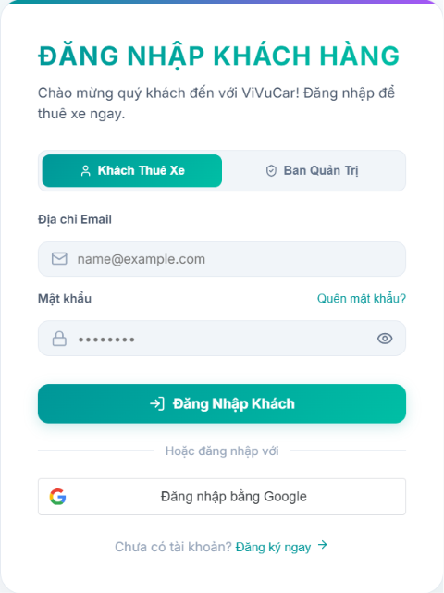

Field Name | Field Type | Description
Email* | Text Box | This is for user to input valid email address for logging in
Password* | Password Box | This is for user to input password for logging in
Login | Button | User clicks to authenticate him/herself into the system with provided email & password
Register | Button | User clicks to redirect to the User Register page for registering new user account to access the system
Forgot Password? | Hyperlink | User clicks to redirect to the Password Reset page for resetting his/her forgot password
Login with Google | Hyperlink | Allow user to login with his/her Google account
“Khách thuê xe” Button | Button | User clicks to sign in as Renter User
“Ban quản trị” button | Button | User clicks to sign in as Owner, Custome Service or Admin.

Database Access
Table | CRUD | Description
User | R | Verify UserName & Password information
Setting, User | R | Specify the authorizations of the logged-in user

SQL Commands:
1/ Verify UserName & Password information
SELECT user_id, full_name, email, image_url, status
FROM user WHERE user_name = ? AND password = ?

2/ Specify the authorizations of the logged-in user
SELECT mapped_values FROM setting WHERE setting_id = ?
SELECT setting_name, mapped_values FROM setting WHERE setting_id IN (?)

1.3 User profile

a. User Profile
This screen allows user to see basic informations such as Name, email, Phone Number, Balance, etc...
Related use cases:
- U03_Login System

UI Design

Field Name | Field Type | Description
Search Fields
“Hủy đặt xe” button | Button | User clicks on it in order to cancel the booking.
“Hoàn thành” button | Button | User click on it to finish the booking.
“Đánh giá” button | Button | Allow users to leave a review of a vehicle that has been rented.
Call button | Button | Click to make a call to customer Service
Write a report | Button | Click to make a new ticket about issue during renting period
Chat button | Button | When a ticket is made, a new chat bubble will appear, allowing user to chat with customer service to clarify the issue
Data Table

2. Rental & Trip Operations

a. My Trips Screen
This screen allows Renter view rented cars, manage payment/deposit status, cancelation or contacting Customer Service for issues relating to personal booking.
Related Use Cases:
- UC19 – Track booking
- UC20 – Cancel Booking & Refund Deposit

UI Design
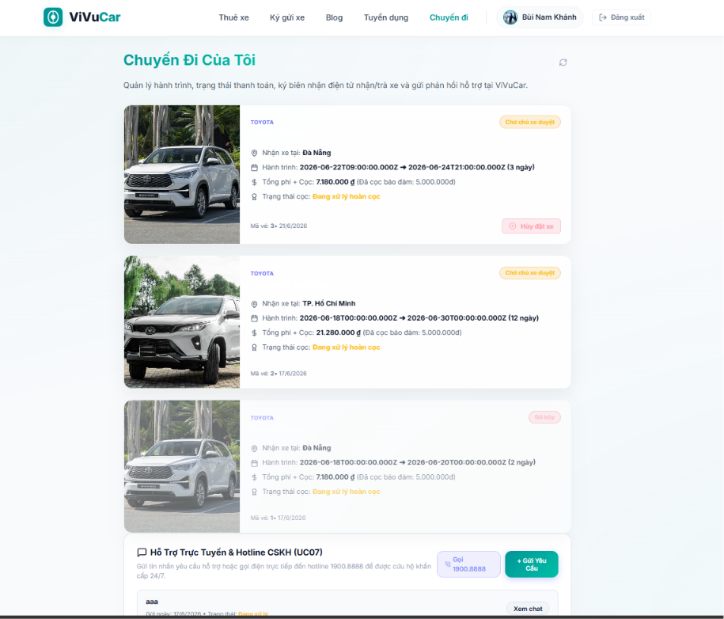

Field Name | Field Type | Description
Search Fields
“Hủy đặt xe” button | Button | User clicks on it to cancel the booking.
“Hoàn thành” button | Button | Users click on it to finish the booking.
“Đánh giá” button | Button | Allow users to leave a review of a vehicle that has been rented.
Call button | Button | Click to make a call to customer Service
Write a report | Button | Click to make a new ticket about issue during renting period
Chat button | Button | When a ticket is made, a new chat bubble will appear, allowing user to chat with customer service to clarify the issue
Data Table
Name | String | Name of the vehicle
Get Vehicle at | Text | Place to pick up the car
Total fee | Longlong | The amount user has to pay (including deposit)
Date | Date/Time | Date of renting
Status | Text | The status of the booking (Approved/ Rejected/ Completed)

Database Access
Table | CRUD | Description
Vehicle | RU | Query the list of current vehicles from the database  Update status of a specific vehicle

SQL Commands:
1/ Query the list of current settings from the database
SELECT setting_id, setting_name, mapped_values, type_id, display_order, status
FROM setting WHERE (setting_type = ?) AND (status = ?) AND (setting_name LIKE ?)

2/ Update status of a specific setting
UPDATE setting SET status = ? WHERE setting_id = ?

IV. Appendix

1. Assumptions & Dependencies
[Record any assumptions that were made when conceiving the project and writing this vision and scope document. Note any major dependencies the project must rely upon for success, such as specific technologies, third-party vendors, development partners, or other business relationships.]
AS-1: Systems with appropriate user interfaces will be available for cafeteria employees to process the expected volume of meals ordered.
AS-2: Cafeteria staff and vehicles will be available to deliver all meals for specified delivery time slots within 15 minutes of the requested delivery time.
DE-1: If a restaurant has its own on-line ordering system, the Cafeteria Ordering System must be able to communicate with it bi-directionally.

2. Limitations & Exclusions

3. Business Rules

ID | Category | Rule Definition
BR-01 | Unique Email | Each email address can only be used to register one account.
BR-02 | Password Policy | Password ≥ 8 characters, containing at least one letter and one number. Stored using bcrypt.
BR-03 | Email Verification | Account must be verified via email link before login. Token expires after 24 hours.
BR-04 | Login Restriction | Unverified accounts are not allowed to log in.
BR-05 | OTP Format | OTP code must consist of 6 random digits.
BR-06 | OTP Expiration | OTP code expires after 10 minutes.
BR-07 | Link Expiration | Email verification link expires after 24 hours.
BR-08 | One-time Use | A verification token or OTP can only be used once.
BR-09 | Email Verification | Account must be verified via email link before login. Token expires after 24 hours.
BR-10 | Authentication Security | Passwords must be matched against the hashed version (bcrypt) stored in the database. No plain-text passwords should be logged or transmitted in plain text.
BR-11 | Secure Google Authentication | Users must authenticate through a secure SSL connection when using Google OAuth.
BR-12 | Server-side Token Verification | The system must verify the Google ID Token on the server side before logging in the user.
BR-13 | Auto Email Verification | Notify with MSG18 if CV information is incomplete when trying to save.
BR-14 | Account Linking | If an account with the same email already exists, the system links the Google ID instead of creating a duplicate account.
BR-15 | Default Role | If no account exists, the system creates a new account with default role Renter.
BR-16 | Logged-in User Only | Only logged-in users can perform logout.
BR-17 | Remove Token | JWT token must be removed from client-side storage after logout.
BR-18 | Clear User State | The application must clear current user state after logout.
BR-19 | Protected Page Restriction | After logout, user must not access protected pages without logging in again.
BR-20 | Email validation rule | The email address inputted for password recovery must exist in the database; otherwise, the system will reject the request.
BR-21 | OTP generation rule | The password recovery OTP code must be a randomly generated 6-digit numeric string (between 100000 and 900000).
BR-22 | OTP expiry rule | The password recovery OTP code is only valid for 10 minutes (600000 ms) from the time it was generated and sent.
BR-23 | Password length rule | New passwords must be encrypted using bcrypt (10 salt rounds) before saving to the database.
BR-24 | Password encryption rule | New passwords must be encrypted/hashed using the bcrypt algorithm with a work factor of 10 salt rounds before being stored in the database.
BR-25 | Authentication Required | User must be logged in to change or set a password.
BR-26 | Password Hashing | Passwords must be hashed using bcrypt before database insertion.
BR-27 | Current Password Required | Users with an existing password must provide the correct current password.
BR-28 | Google Account Exception | Accounts with no existing password do not require current password when setting one for the first time.
BR-29 | Password Confirmation | New Password and Confirm New Password must match.
BR-30 | Login Required | The User must be logged in to view or edit profile information.
BR-31 | Active Account Required | The User account must be active and accessible before profile information can be viewed or updated.
BR-32 | Own Profile Only | The User can only view and edit their own profile unless they have admin permission.
BR-33 | Mandatory Full Name | Full Name is mandatory and cannot be blank.
BR-34 | Editable Profile Fields | The User may update Full Name, Phone Number, Date of Birth, Bio/Description, and Avatar. Email Address is displayed as account information and is not edited in this use case.
BR-35 | Phone Number Format | Phone Number must follow the accepted phone number format before being saved.
BR-36 | Optional Bio and Avatar | Bio/Description and Avatar are optional fields.
BR-37 | Image Format | Avatar upload supports PNG, JPG, and JPEG formats only.
BR-38 | File Size Limit | Avatar image size must not exceed 10MB.
BR-39 | Base64 Avatar Storage | Avatar image is converted to base64 and stored in the avatar_url field, unless the initial avatar is loaded from a Google account URL.
BR-40 | Activity Logging | The system must record the profile update activity after a successful update.
BR-41 | KYC Role Permission | Only Renters and Owners can submit KYC documents.
BR-42 | Required Documents | Renters must upload CCCD Front, CCCD Back, and Driver’s License.
BR43 | Driver License Requirement | Renters must have a verified Driver’s License before booking a car.
BR44 | File Format | Uploaded documents must be PNG, JPG, or JPEG.
BR45 | File Size Limit | Each uploaded document must not exceed 10MB.
BR46 | Name Matching | The full name from CCCD QR code must match the registered full name, case-insensitive and without accents.
BR47 | Login Required | User must be logged in to link a bank account.
BR48 | Bank Required for Withdrawal | A linked bank account is required before requesting withdrawal.
BR49 | Name Matching | Account Holder Name must match the user’s verified Full Name.
BR50 | Required Fields | Bank Name, Bank Account Number, and Account Holder Name are mandatory.
BR51 | Mask Sensitive Data | Bank account number should be masked when displayed on the client interface.
BR52 | Bank account linking rule | To successfully upgrade to a Car Owner, users must provide a valid bank name, account number, and account holder name.
BR53 | KYC owner validation rule | A renter must have their driver's license status marked as verified in the database before listing a vehicle or becoming a Car Owner.
BR54 | Auto-escalation rule | If a user with the renter role successfully submits a new vehicle for listing, the system automatically escalates their database role to owner.
BR55 | Display Eligibility Status | Only vehicles that have been approved by the Admin/Customer Service and are actively set to "Active" or "Available" status by the Car Owner can be displayed in the listing.
BR56 | Active Vehicle Only | Only vehicles with is_active = 1 can be displayed.
BR57 | Available Vehicle Only | Only vehicles with status Available can be displayed.
BR58 | Date Validation | Return Date must be at least 1 day after Pick-up Date.
BR59 | Filter Matching | Search results must match all selected filter criteria.
BR60 | Premium Filter | Premium filter displays vehicles with base daily price greater than 1,500,000 VND.
BR61 | Review Eligibility | Only Registered Users who have successfully completed a rental order for that specific car are allowed to submit a rating and review.
BR-62 | Rating Calculation | The average star rating of a car must be automatically re-calculated and updated in real-time whenever a new approved review is submitted.
BR63 | Published Policy Only | Only published policies and FAQ articles are visible to users. Draft or archived content must not be displayed.
BR64 | FAQ Search | The system searches FAQ articles by title and content keywords and displays matching results.
BR65 | Overlap Prevention | A car cannot be booked for overlapping periods. Availability is validated before confirming.
BR66 | Renter Only | Only authenticated Renters can process booking payments.
BR67 | Pending Status Required | Booking must be in Pending/Temporary status before payment.
BR68 | Total Payment Split | Payments include the rental fee and security deposit. The gateway supports either full payment or a 30% initial deposit configuration.
BR69 | Fixed Security Deposit | Standard security deposit is fixed at 5,000,000 VND unless configured otherwise.
BR70 | Gateway Verification | External payment results must be verified via secure hash signature before updating the database.
BR71 | Wallet Balance Check | Wallet payments require the user's balance to be $\ge$ the total required checkout amount.
BR72 | Session Expiration | Gatewưay links and dynamic VietQR codes strictly expire after 10 minutes.
BR73 | Booking Status Workflow | Only valid booking statuses (Pending, Approved, Ongoing, Completed, Cancelled) may be displayed in the Track Booking screen.
BR74 | Booking Ownership | Users may only view and track bookings associated with their own account
BR75 | Cancellation Refund Policy | Cancel > 48 h before trip: 100% refund. Cancel 24–48 h: 50% refund. Cancel < 24 h: no refund.
BR76 | Cancellation Deadline | Cancellation is only allowed before the rental start time. Once the trip has started, cancellation is locked.
BR77 | Handover Integrity | The handover form cannot be submitted unless all required vehicle condition photos (Front, Rear, Left, Right) have been uploaded successfully.
BR78 | Electronic Confirmation | Both the Car Owner and the Renter must electronically confirm the handover before the booking status changes to Ongoing or Completed.
BR79 | One Review Per Booking | Each completed booking can receive only one review from the renter. Once submitted, the review cannot be submitted again.
BR80 | Calculation | The system recalculates the vehicle's and car owner's average rating using: Average Rating = Total Stars ÷ Total Reviews, rounded to one decimal place.
BR81 | Active Trip Requirement | Emergency reports can only be submitted while booking status is "In Progress".
BR82 | Severity Escalation | Incidents of type "Accident" are automatically escalated to Admin in addition to CSKH and Car Owner.
BR 83 | Dispute Timeline | A formal complaint regarding a trip must be submitted within a maximum of 72 hours (3 days) after the electronic handover form is signed at vehicle return. Late submissions will be rejected automatically.
BR84 | Evidence Integrity | Dispute complaints must contain at least 1 image attachment verifying the physical condition, receipt, or transaction error. General complaints without clear visual proof may be dismissed during initial CSKH screening.
BR85 | Minimum Thresholds | Outbound wallet withdrawals must adhere to platform limits (e.g., Minimum 50,000 VND per transaction request).
BR-86 | Mandatory vehicle fields | The system must reject a vehicle registration request if any of the following fields are missing: Brand, Model, Seats, Price Per Day, Location, and Plate Number.
BR-87 | Moderation dependency | All newly registered vehicles must be placed in a pending_moderation status and cannot be searched or rented by guests until verified and approved by the CSKH/Admin.
BR-88 | Ownership verification | The system must verify that the logged-in user's ID matches the ownerId of the vehicle associated with the booking before allowing approval or rejection of a rental request.
BR89 | Revenue Calculation | Net revenue = total rental fee × (1 − 15% platform fee). Both gross and net amounts are displayed.
BR90 | Data Scope | Only bookings with status "Completed" are included in revenue statistics. Cancelled or in-progress bookings are excluded.
BR-91 | Self-deletion restriction | The system must block any logged-in administrator from deleting their own active account.
BR-92 | Role type enforcement | The user role can only be assigned to one of the following predefined string literals: 'renter', 'owner', 'cskh', or 'admin'.
BR-93 | Rejection justification | The system must verify that the logged-in user's ID matches the ownerId of the vehicle associated with the booking before allowing approval or rejection of a rental request.
BR94 | Decision Authority | Only users with Admin role can approve or forfeit deposits. CSKH may flag cases but cannot make the final decision.
BR95 | Policy Compliance | Refund decisions must align with the platform's cancellation policy (BR07). Deviations require a documented reason.
BR96 | Audit Log | Every deposit decision (Admin ID, timestamp, decision type, reason) is permanently logged and cannot be deleted
BR97 | Staff Authorization | Only Admin or CSKH can access KYC approval function.
BR98 | Pending Only | Only KYC records with Pending status can be approved or rejected.
BR99 | Rejection Reason | KYC rejection must include a rejection reason.
BR100 | Service Restriction | Rejected KYC prevents user from renting cars or listing personal vehicles.
BR101 | Audit Log | Each KYC review must record reviewer ID and review timestamp.
BR102 | Vehicle Approval Authority | Only Customer Service staff are authorized to approve or reject newly submitted vehicle listings
BR103 | Vehicle Document Requirement | Vehicle listings must include valid registration and insurance documents before approval
BR104 | Support Ticket Audit Trail | All ticket responses, status changes, and actions performed by Customer Service must be recorded in the system.
BR105 | Support Ticket Status Management | Support tickets must maintain one of the following statuses: Open, In Progress, Resolved, or Closed.
BR106 | Complaint Access Control | Guests and registered users can access AI Support Chatbot.
BR107 | Complaint Status Management | AI responses must stay within ViVuCar business operations.
BR108 | Complaint Evidence Retention | Backend must not expose GEMINI_API_KEY to the client.
BR109 | Empty Message Block | Empty messages must not be submitted to the chatbot API.
BR110 | Rate Limit | The system should limit message frequency to reduce spam and API abuse.
BR111 | Incident Status Management | Every incident report must maintain one of the following statuses: Reported, Investigating, Resolved, Closed.
BR112 | Incident Evidence Requirement | Every incident report must include at least one supporting image or document before Customer Service begins processing.
BR113 | Incident Notification | The system must notify Customer Service immediately when a new incident report is submitted.
BR114 | Incident Audit Trail | All incident handling activities, status updates, and resolution notes must be recorded in the system audit log.
BR115 | Review Moderation Policy | Customer Service may hide or remove reviews containing offensive, misleading, or inappropriate content.
BR116 | Review Status Management | Every review must maintain one of the following statuses: Visible, Hidden, or Removed.
BR117 | Review Audit Trail | Every review moderation action must be recorded with moderator, date, and reason.
BR118 | Report Generation | Reports must be generated based on real-time system data.
BR119 | Report Export | Reports can be exported in PDF or Excel format.
BR120 | Report History | All generated reports must be stored for future reference.
BR121 | OCR Data Extraction | The AI OCR service automatically extracts identity information from uploaded documents.
BR122 | Manual Verification | Customer Service must review and verify all extracted information before approving KYC.
BR123 | KYC Data Security | All uploaded identity documents and extracted information must be securely stored and protected.
BR124 | Public Access | Guests and registered users can access AI Support Chatbot.
BR125 | Business Scope | AI responses must stay within ViVuCar business operations.
BR126 | API Key Security | Backend must not expose GEMINI_API_KEY to the client.
BR127 | Empty Message Block | Empty messages must not be submitted to the chatbot API.
BR128 | Rate Limit | The system should limit message frequency to reduce spam and API abuse.

4. ..

